

Compte Rendu Complet de TP ERP
Amira Mrabet
Ahmed Riadh Hedhili
L2CS02

TP1
Ex1:
- - An Information System (IS) is an organized set of people, data, procedures, and tools that allow information to be collected, processed, stored, and disseminated within an organization.
- A Computer System: This is the technical part of an information system and includes computers, software, databases, and companies.
2) A business process (processus métier) represents a series of organized activities aimed at producing added value and responding to a specific objective within the organization. Examples include sales, recruitment, and production processes.
3) Business processes define what an organization does, and information systems support and automate these processes, contributing to improved coordination between departments, faster business execution, and smoother operations.
4) Examples of ERP systems:
BAGE, odoo, Microsoft Dynamics, Oracle ERP, SAP, ERPNext

5) Examples of the most important ERP modules:
- Sales and Purchasing Management
- Inventory Management
- Accounting and Finance
- Human Resources
- Production
- Customer Relationship Management (CRM)
- Maintenance
- Marketing
6) Odoo Community: Free and open source, it supports basic functions but lacks official support and advanced applications.
Odoo Enterprise: Paid and closed source, it offers advanced functions, official support, and advanced applications.
7) Benefits of an ERP system for an organization:
1. Data standardization and integration
2. Improved productivity
3. Reduced errors
4. Support for decision-making
5. Process automation
6. Time and cost savings
7. Improved coordination between different departments

TP2
Ex1: (Modélisation d'un processus simple)
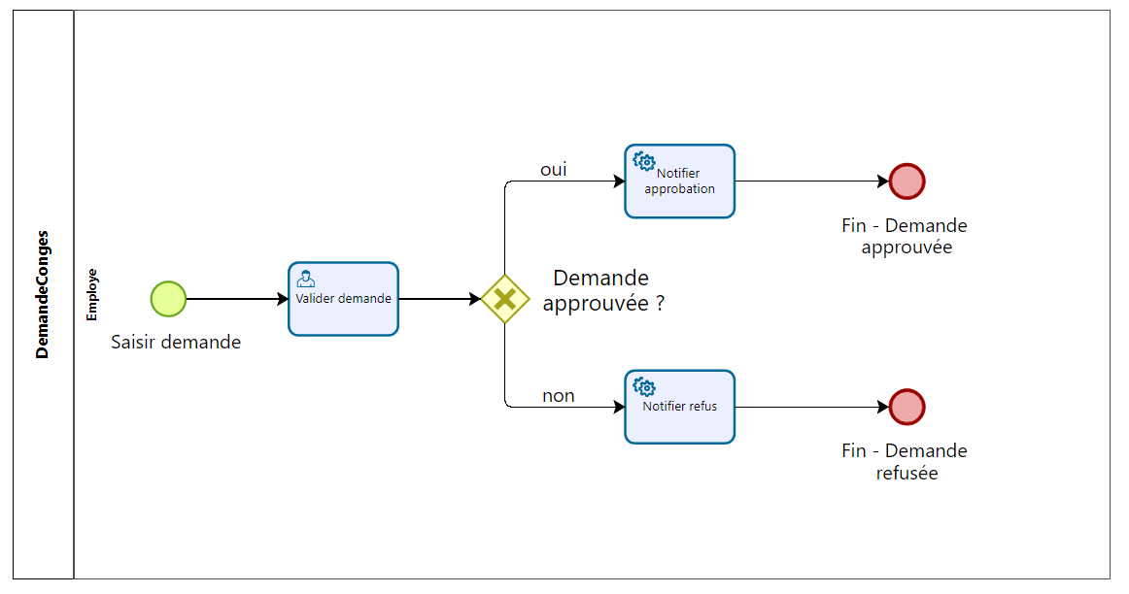
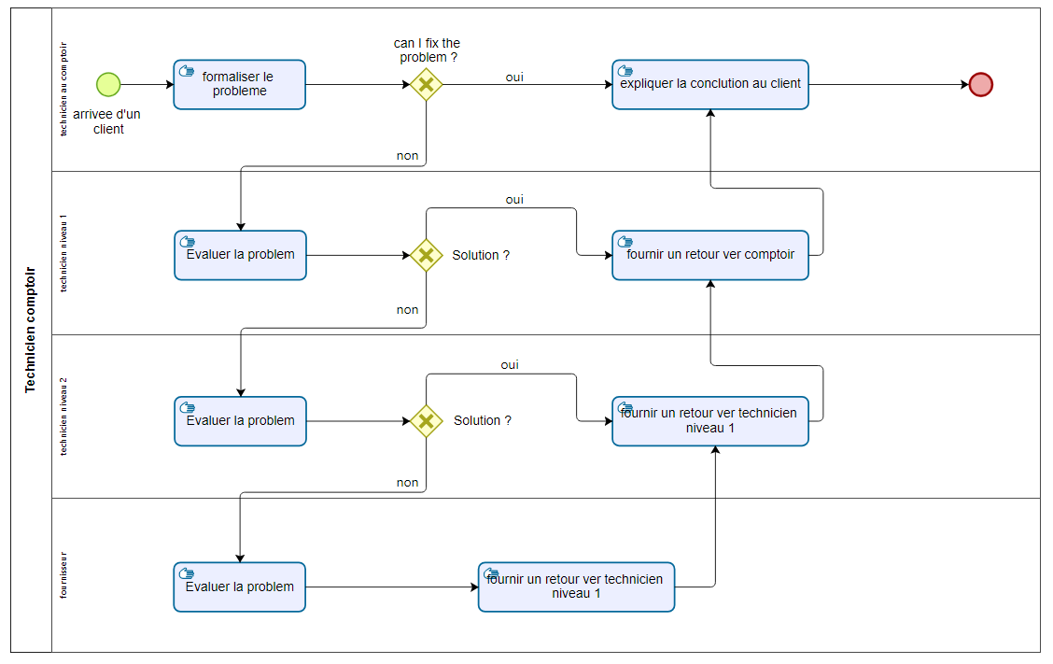
Ex2: (Modélisation d’un processus de gestion des incidents)

TP3
Game purchase website "GamingAA"
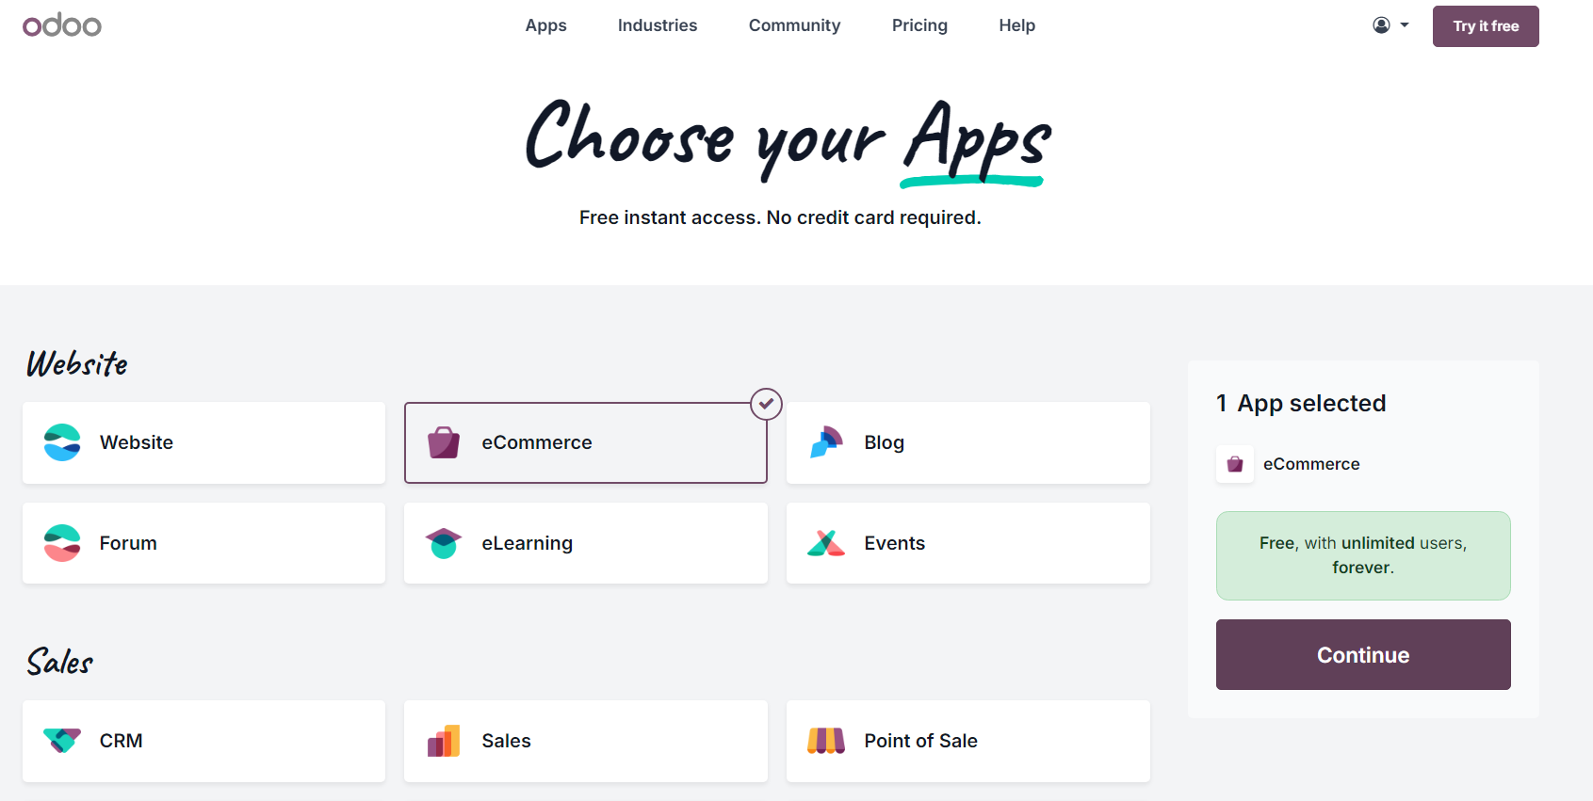
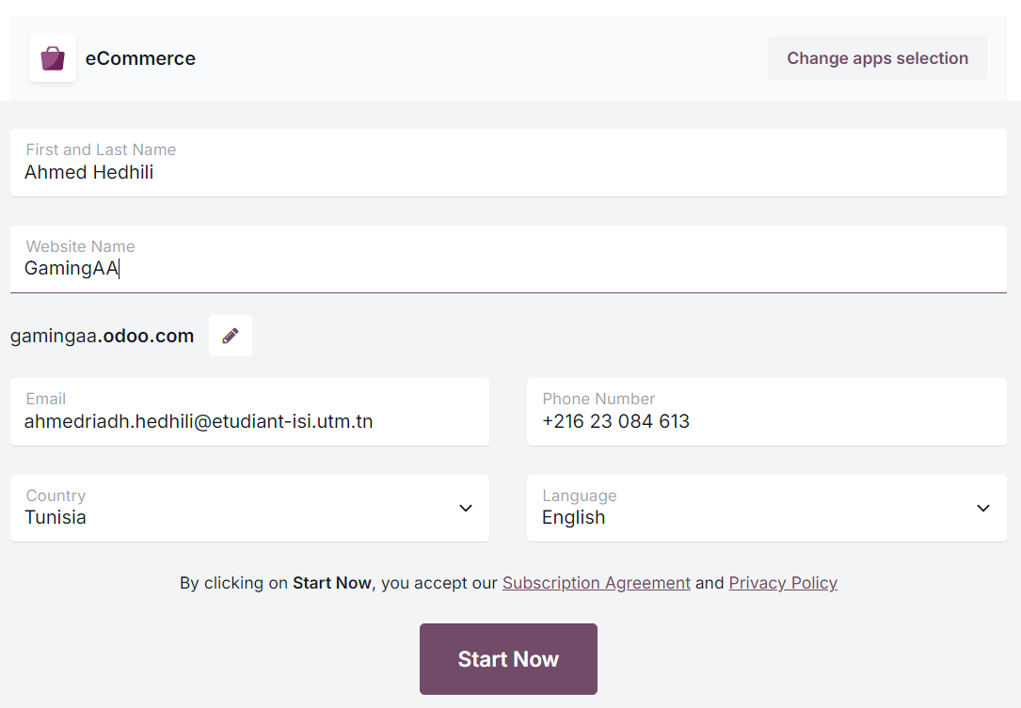

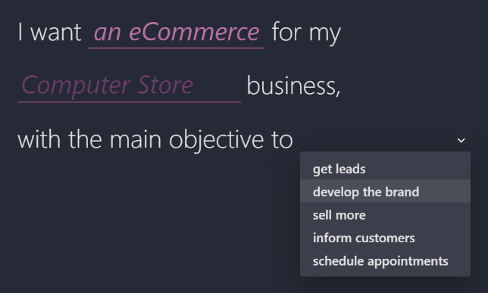
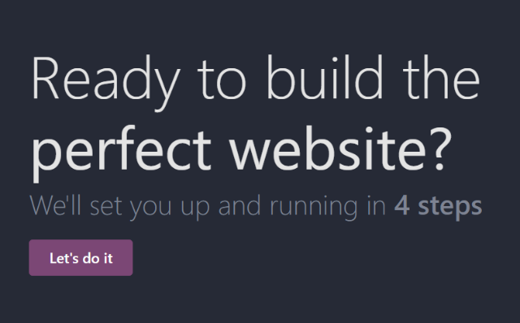

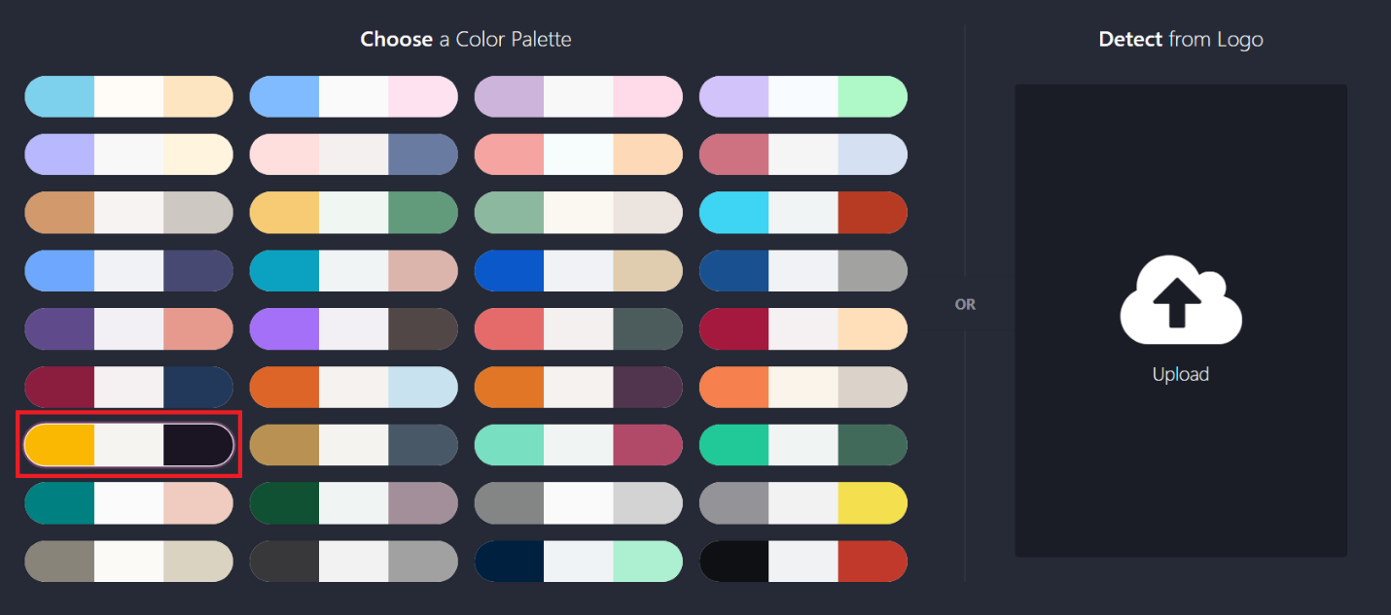

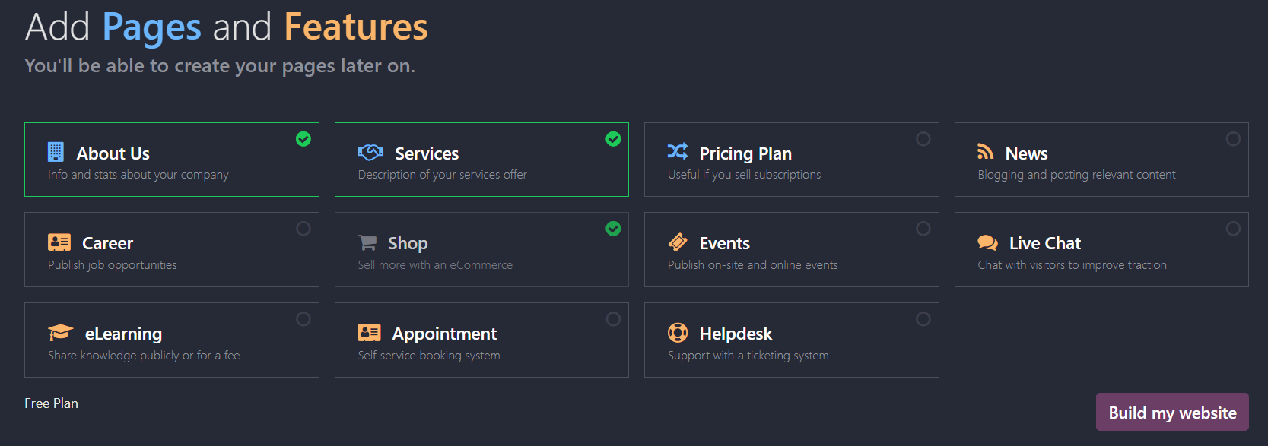

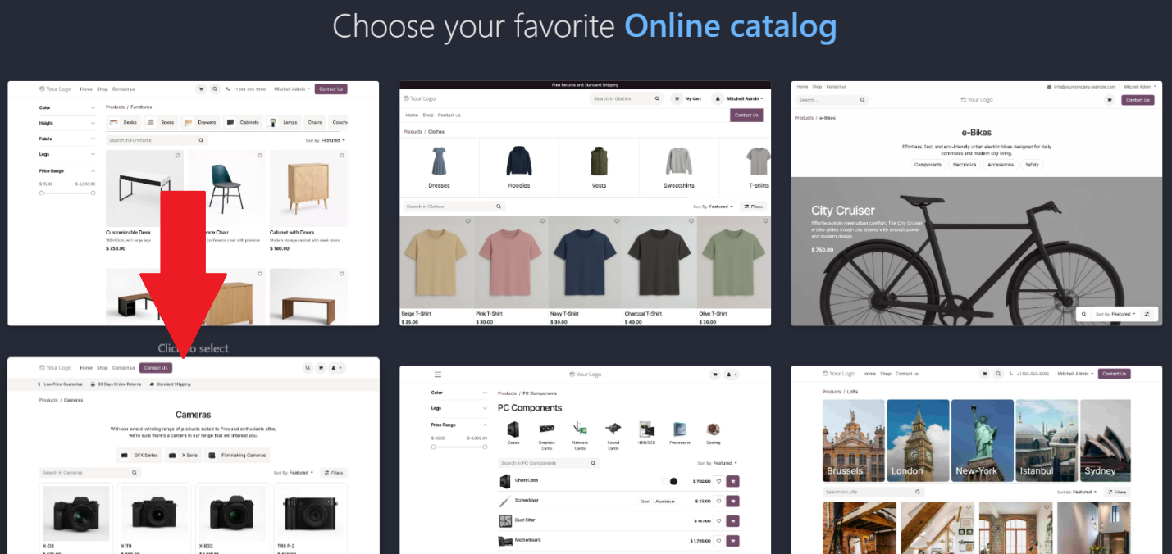

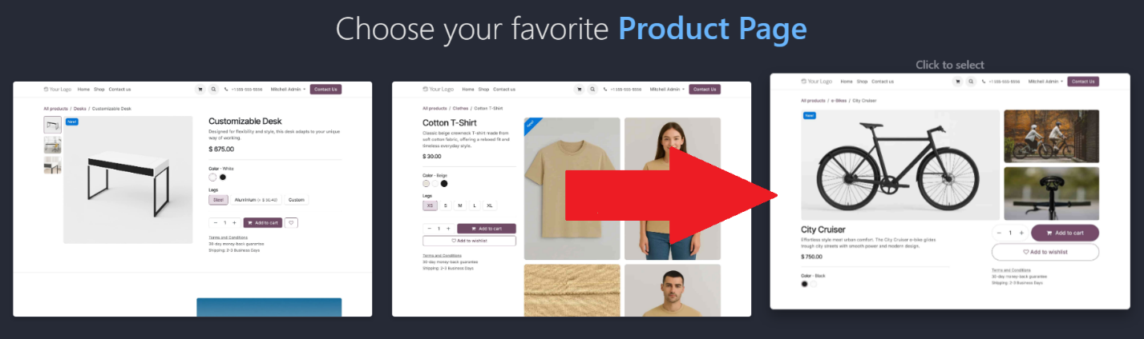

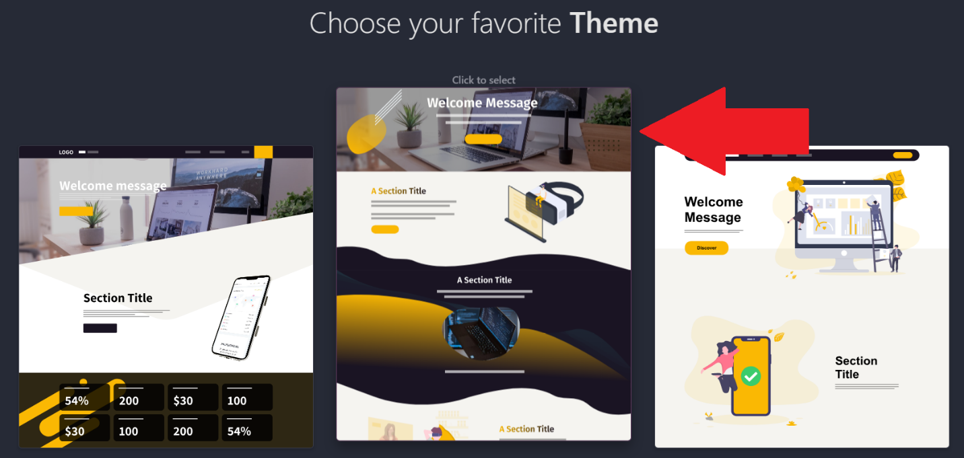

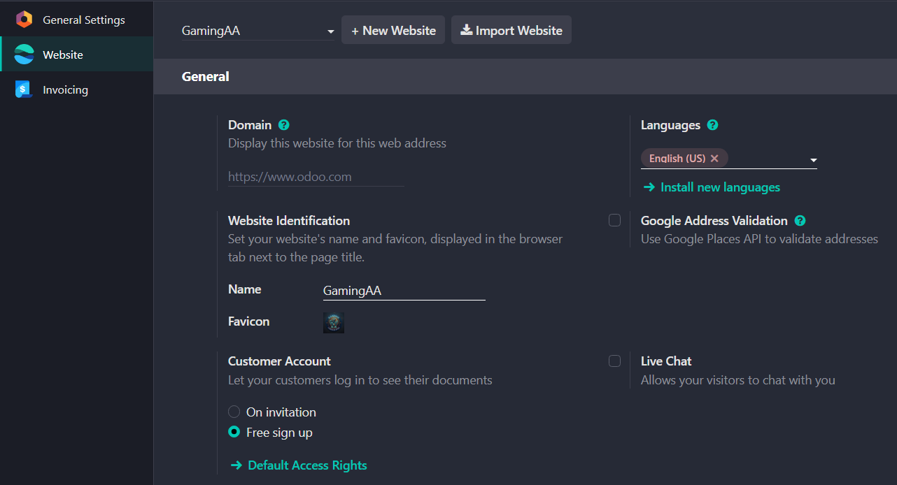

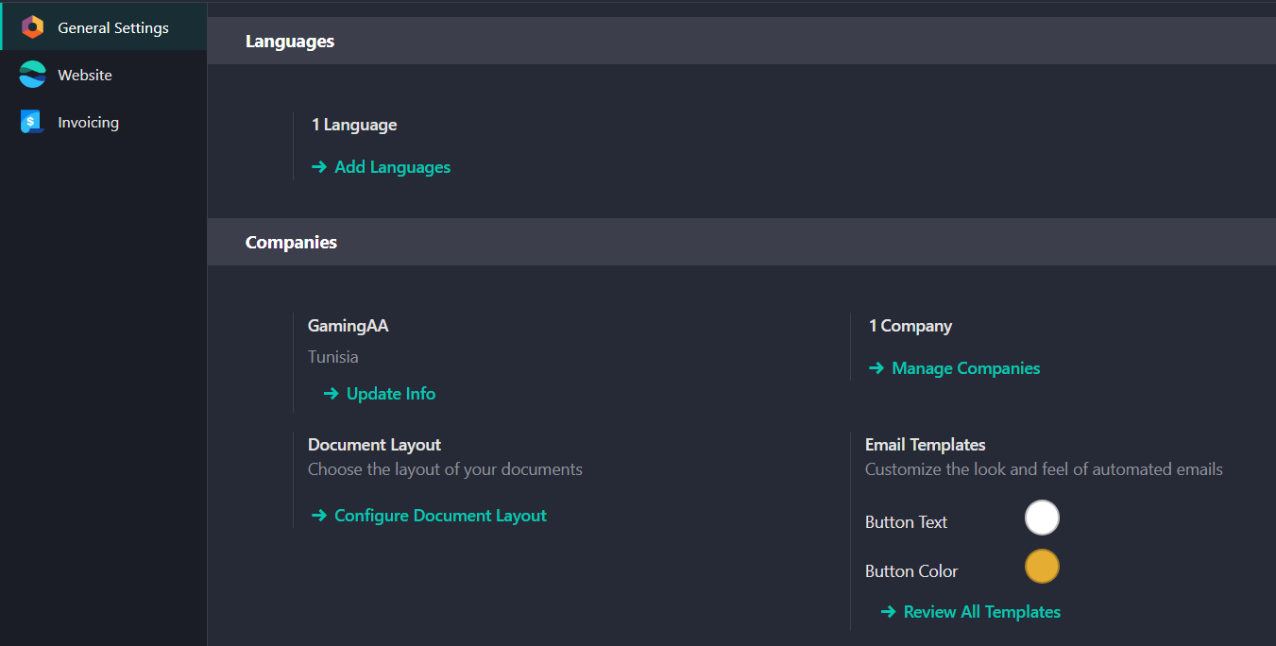

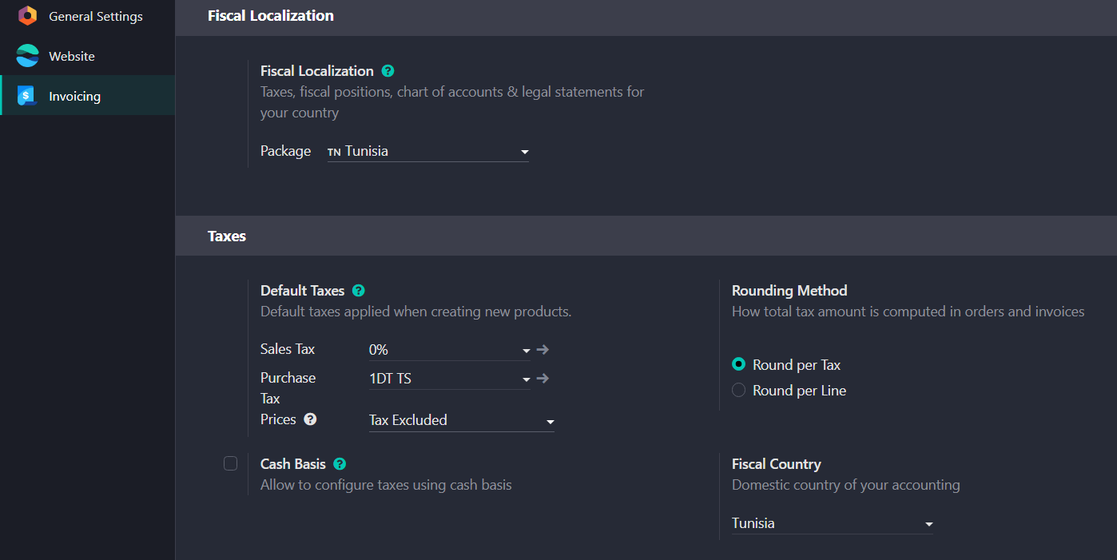

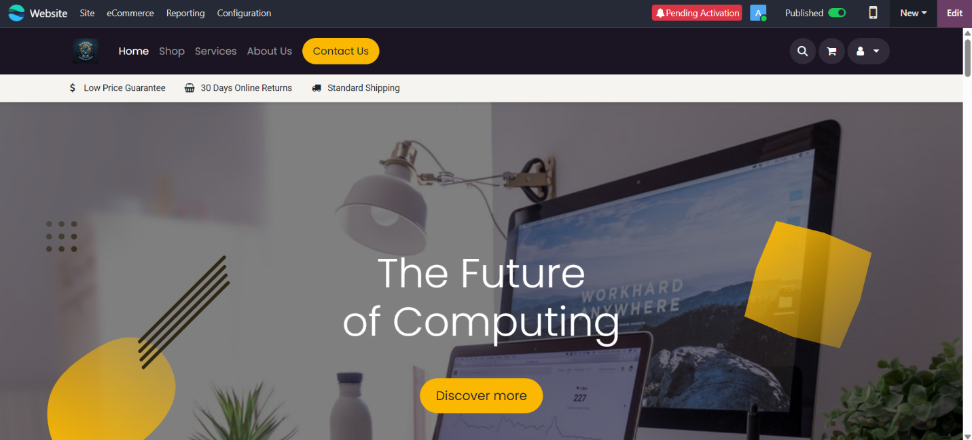

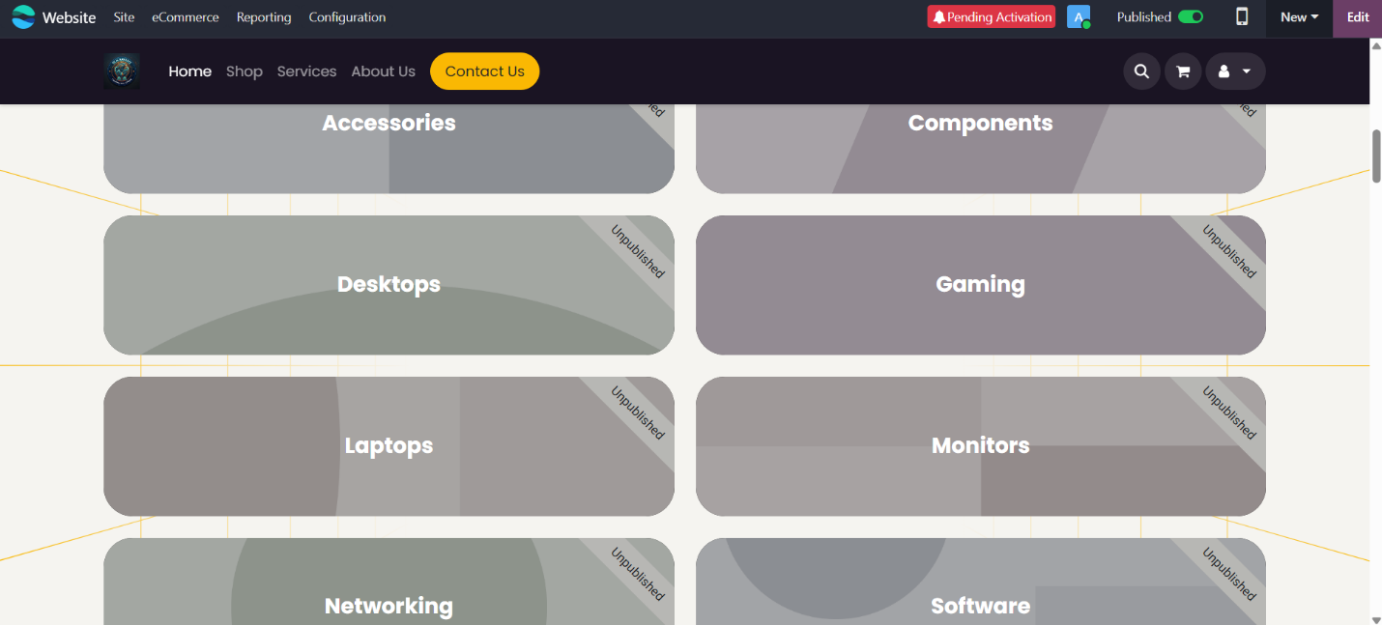

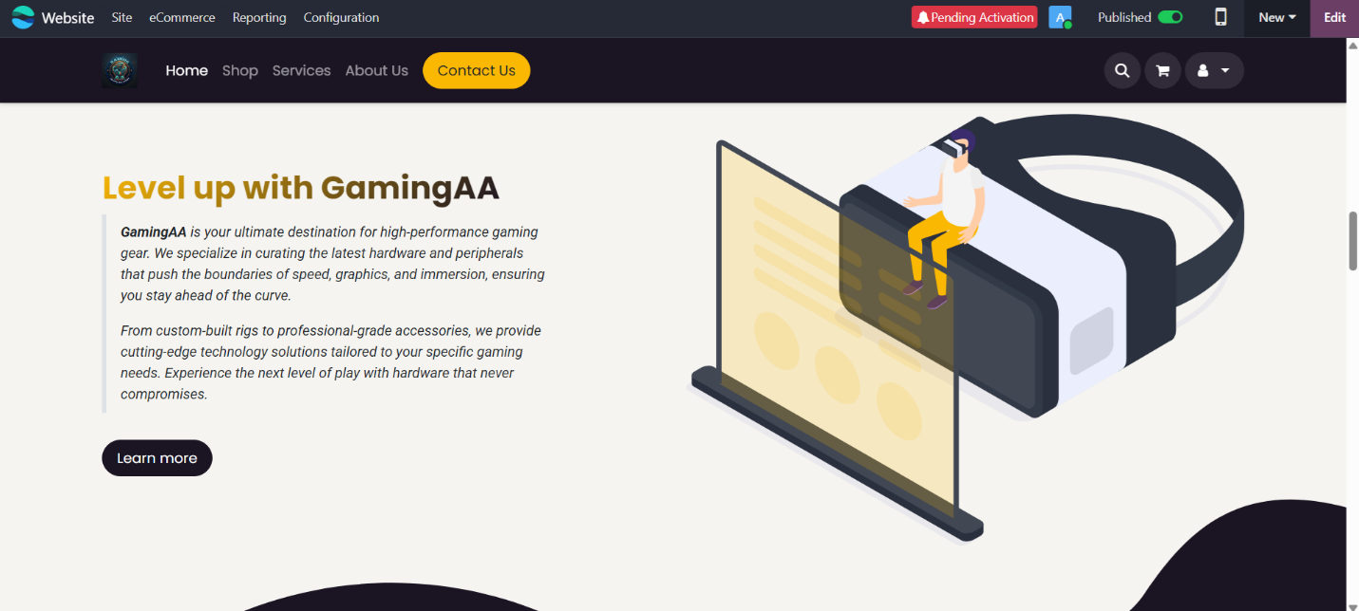

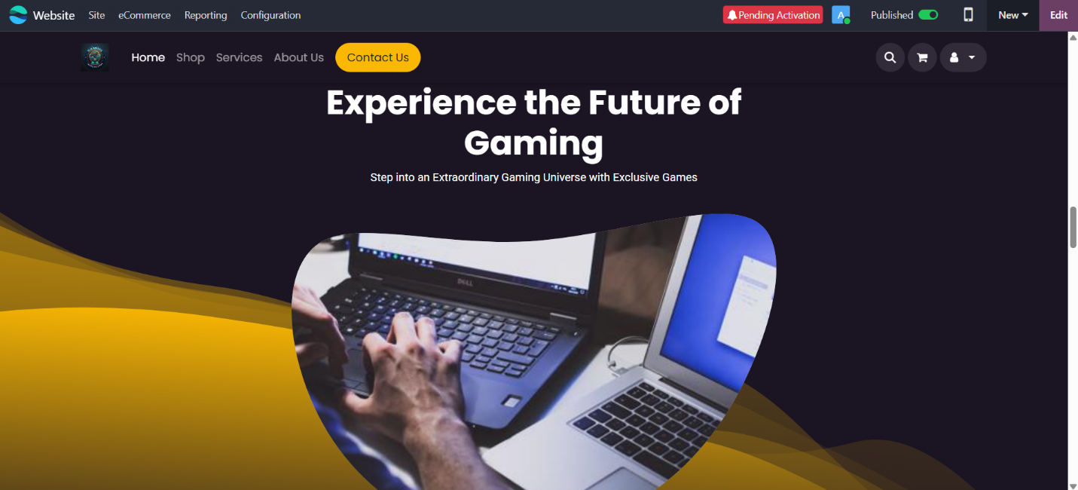

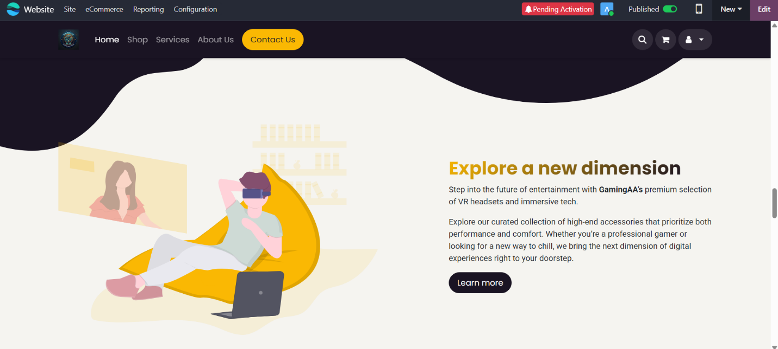

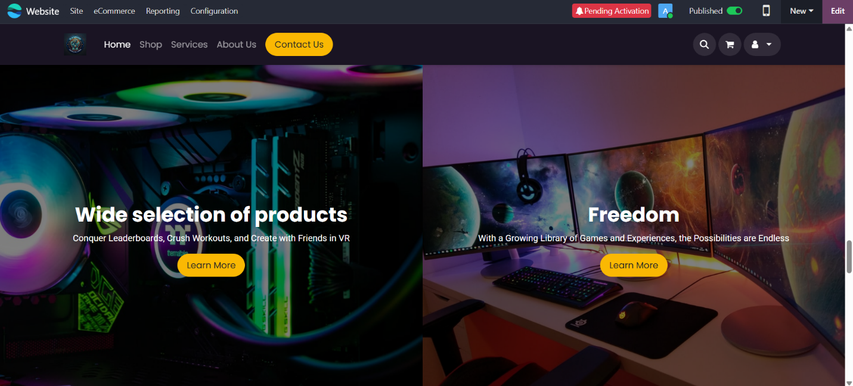

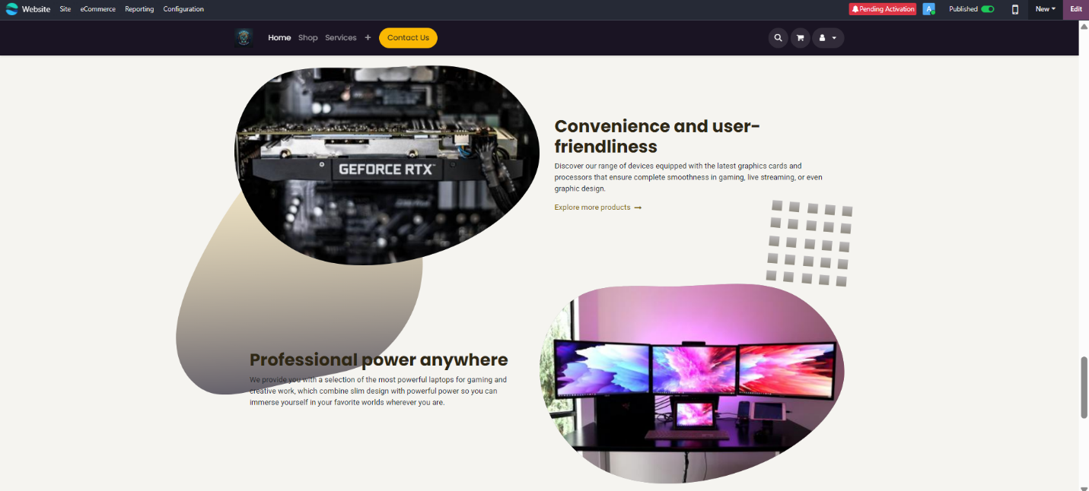

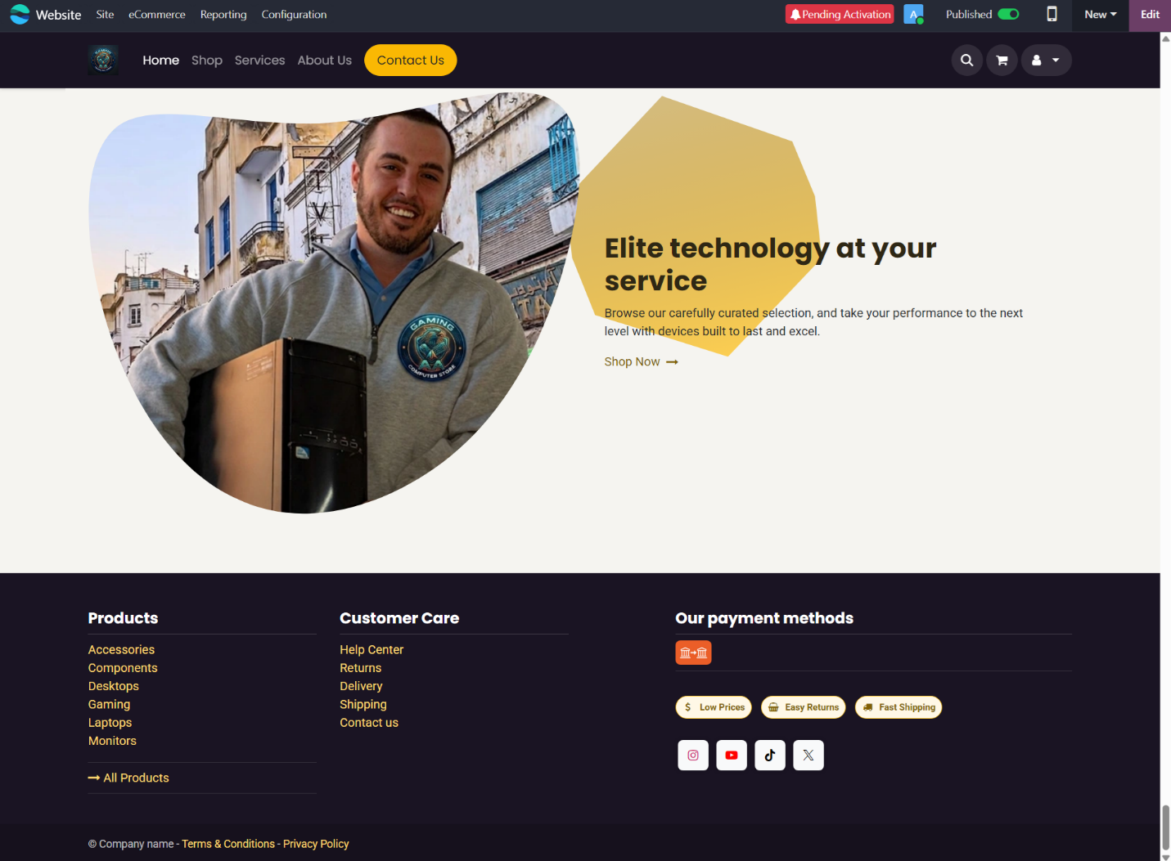

Mini-Project TP ERP
Amira Mrabet
Ahmed Riadh Hedhili
L2CS02

Project Introduction
This project aims to introduce and practically implement an Enterprise Resource Planning (ERP) system using the Odoo platform. This report focuses on creating a virtual company and managing its core operations, such as sales, purchasing, inventory, and accounting.

Activity 1: Company setup
Basic company information:
https://intoy.odoo.com
- Company name: Intoy
- City: Tunis
- Country: Tunisia
- Currency: TND (Tunisian Dinar)
- Phone: +216 23 084 613
- Email: info@ intoy.odoo.com
- Text slogan: “Gifts of joy for every child”
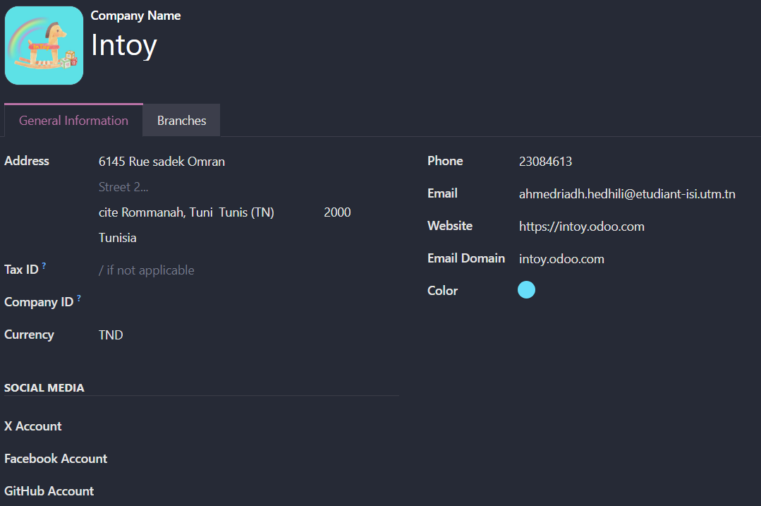
The data has been successfully saved in the system.

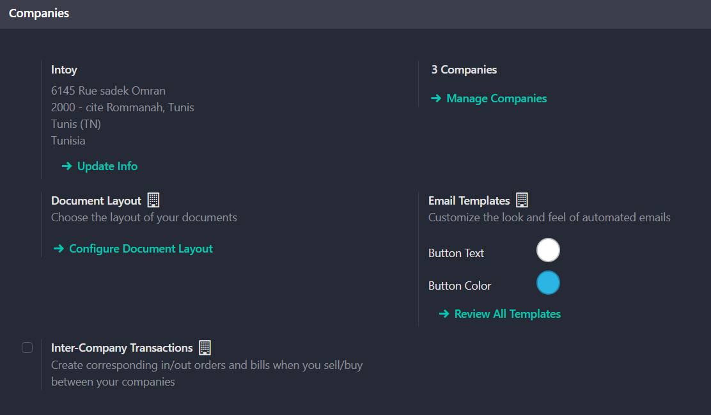

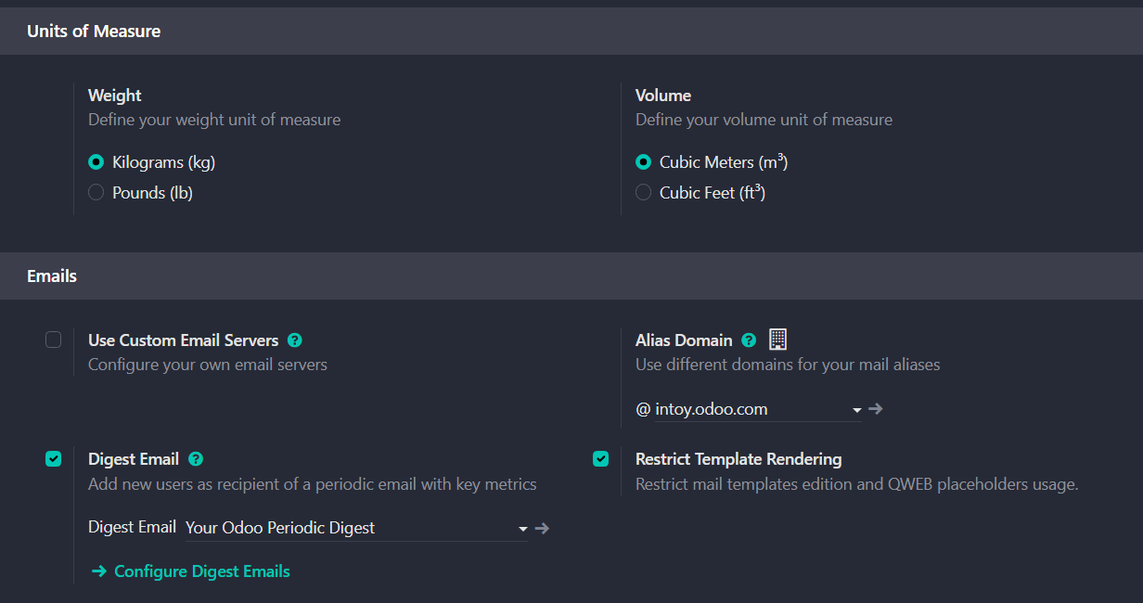

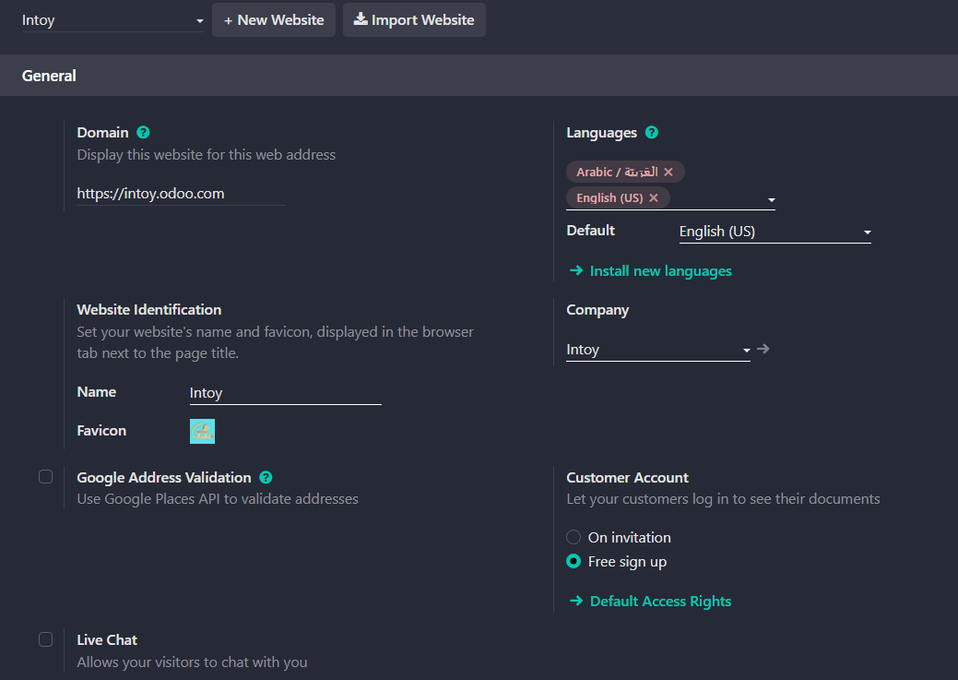

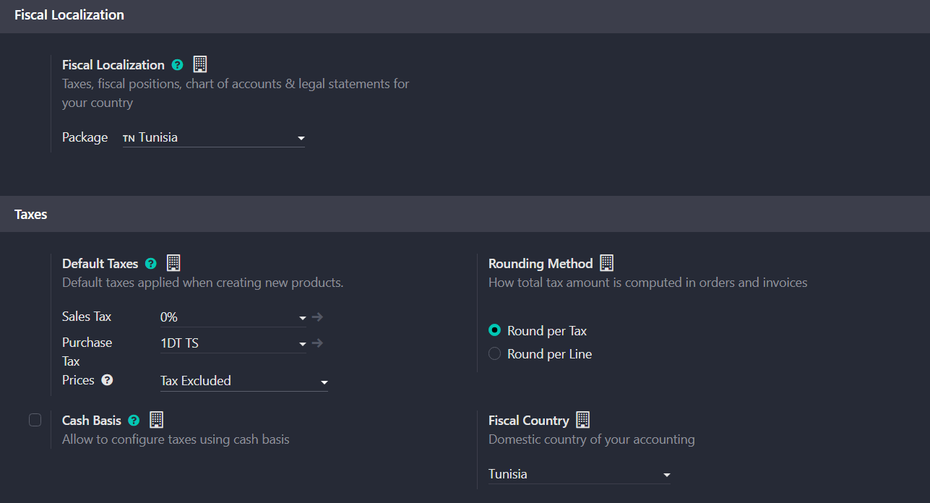

Activity 2: User Management
Create different users with different permissions to work in the store. Each employee will have a specific role and certain powers.

First user:
- Name: Mohamed Ammar
- Email: Mohamed@intoy.odoo.com
- Username: Med_sales
- Role: Sales Manager
- Powers: He can create sales orders and manage customers
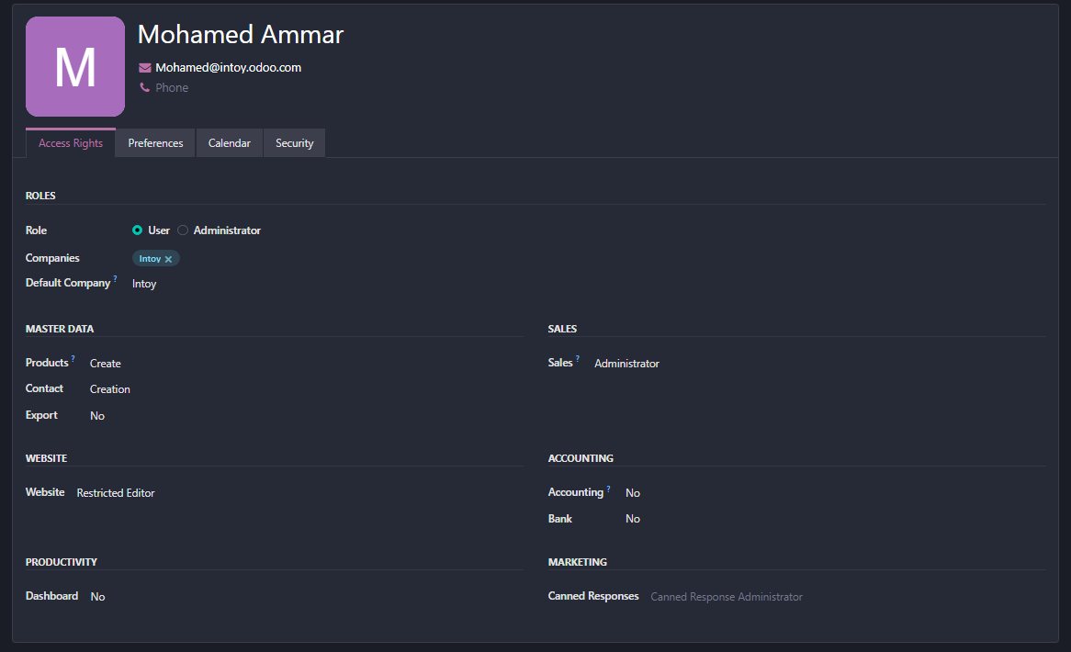

Second user:
- Name: Fatima Ali
- Email: Fatima@intoy.odoo.com
- Username: fatim_accountant
- Role: Accountant
- Powers: She can manage invoices and payments

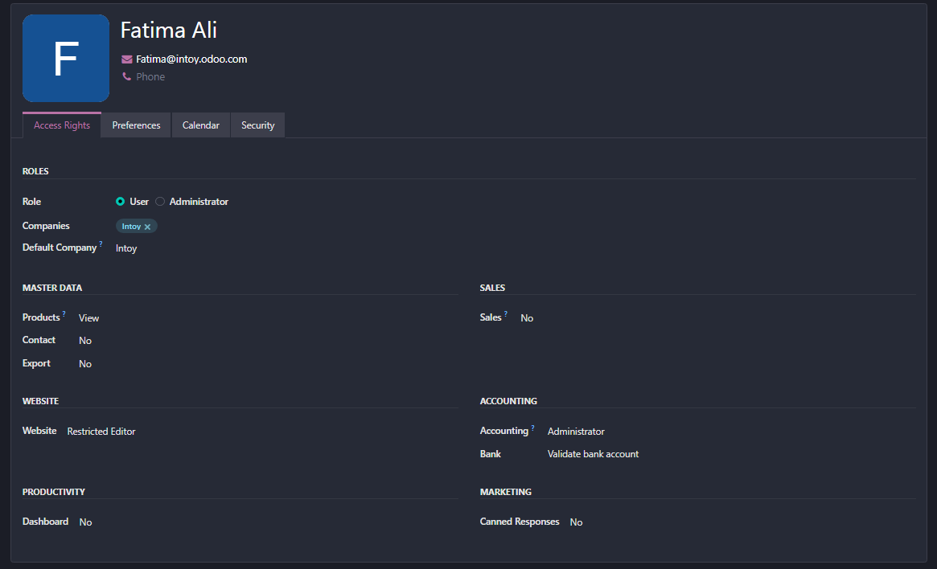

Third user:
- Name: Sarah Hamdi
- Email: sarah@intoy.odoo.com
- Username: sar_marketing
- Role: Marketing
- Powers: She can manage promoting products to the right audience
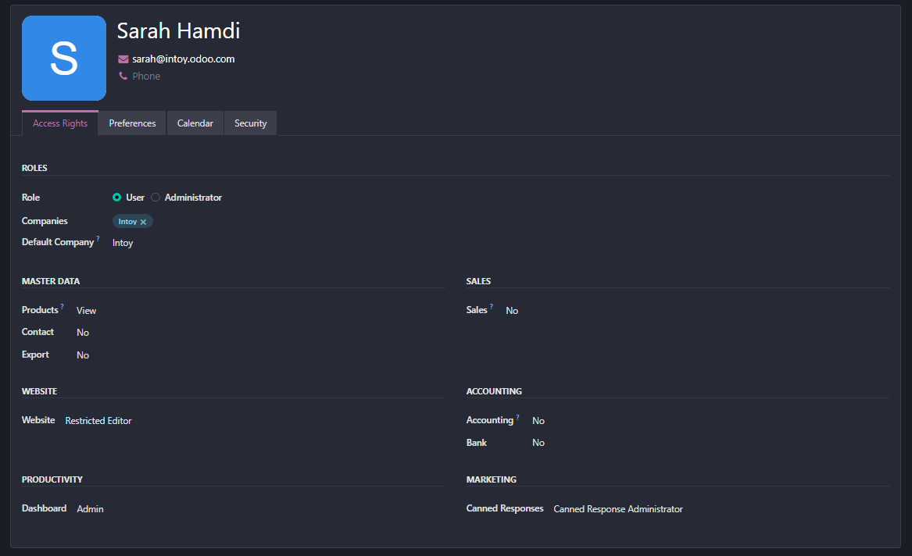

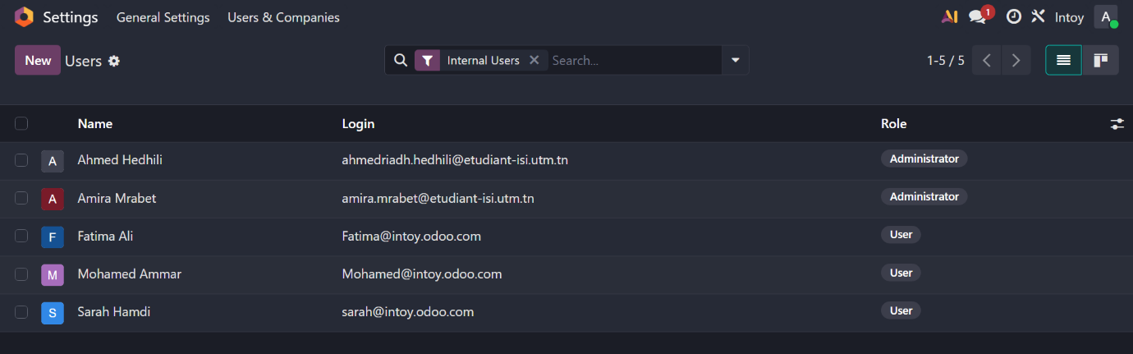

Activity 3: Module Installation
Install the essential modules needed to manage the toy and doll shop. Each module adds new features to the system.
The following four core modules must be installed:
- CRM (Customer Relationship Management)
• Uses: Managing customer information and communicating with customers
•Features: Customer tracking, sales opportunities, communication
- Sales
• Uses: Creating sales orders and product deliveries
• Features: Sales orders, invoices, deliveries

- Purchases
• Uses: Creating purchase orders from suppliers
• Features: Purchase orders, receiving goods, supplier invoices

- Accounting
• Uses: Managing invoices, payments, and financial reports
• Features: Accounting entries, reports, account management
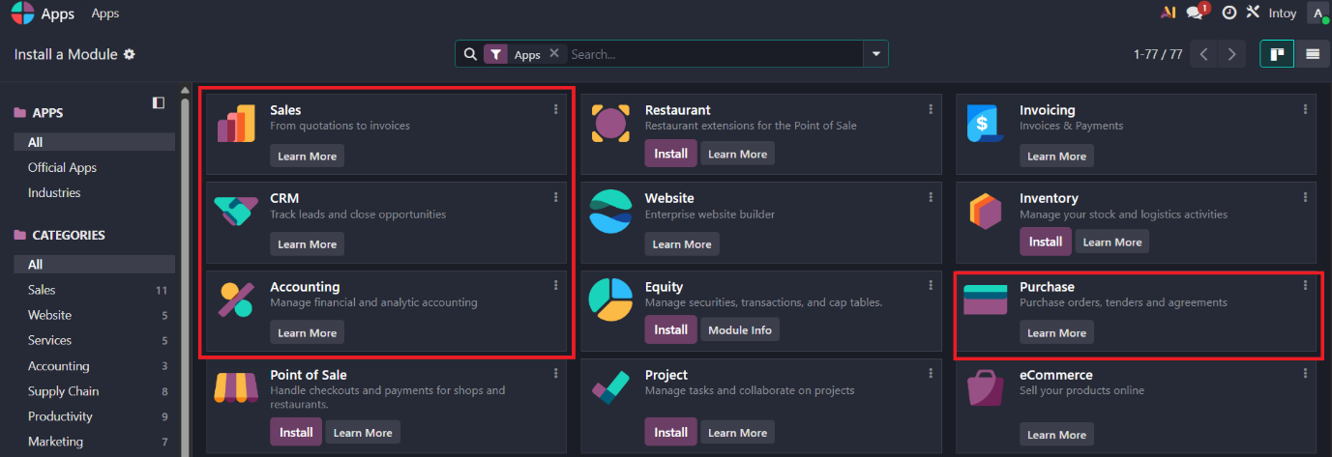

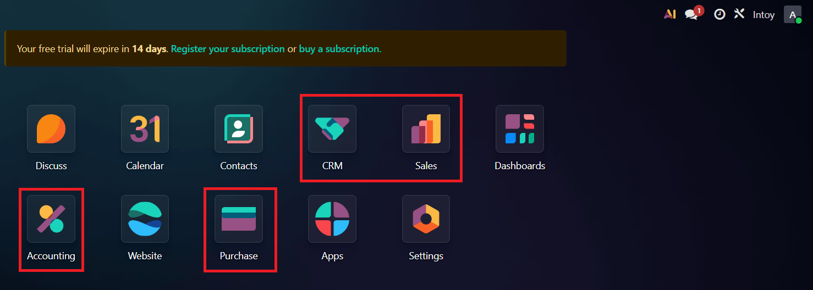

Activity 4: Partner Management
To define partners in Odoo, the process typically involves navigating through the respective modules:
• For Customers: Sales > Customers > Create
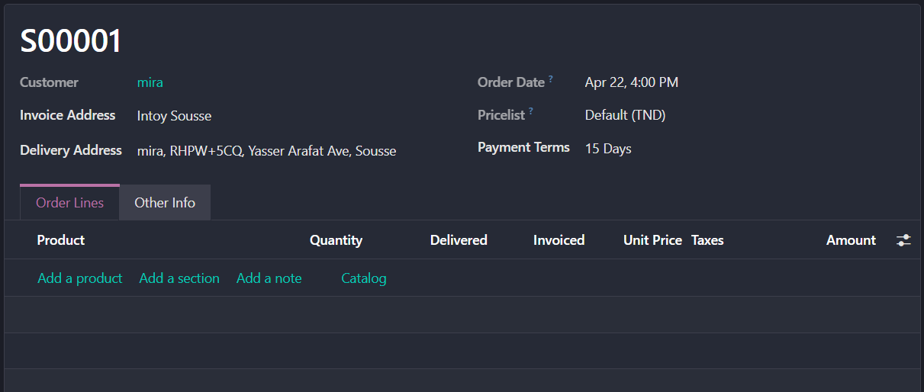

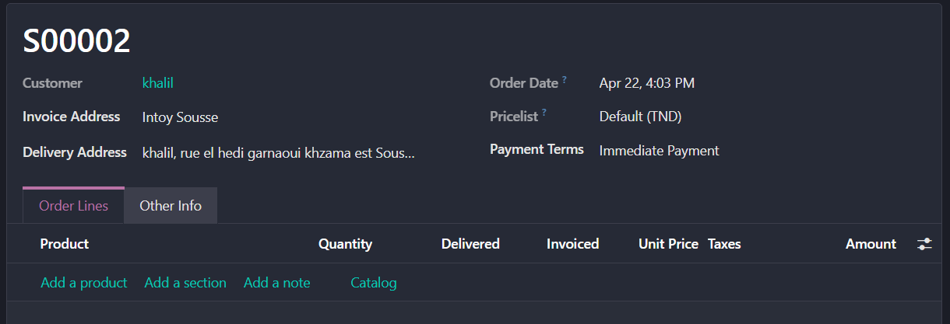
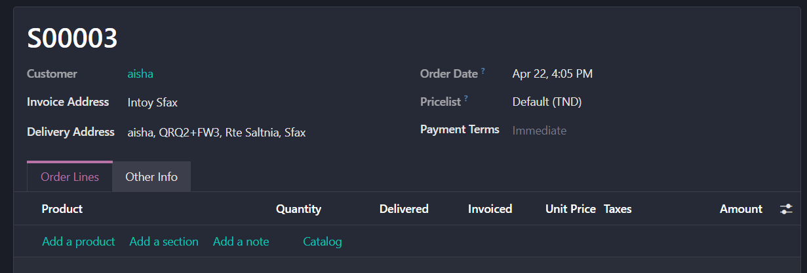
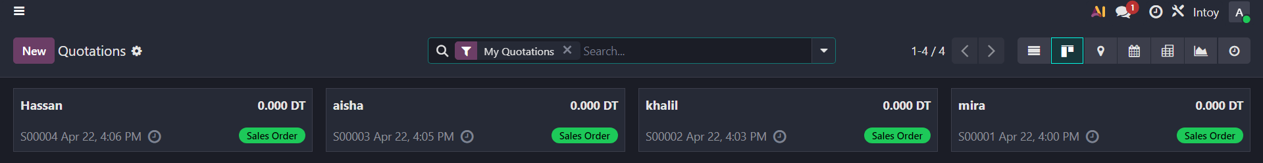
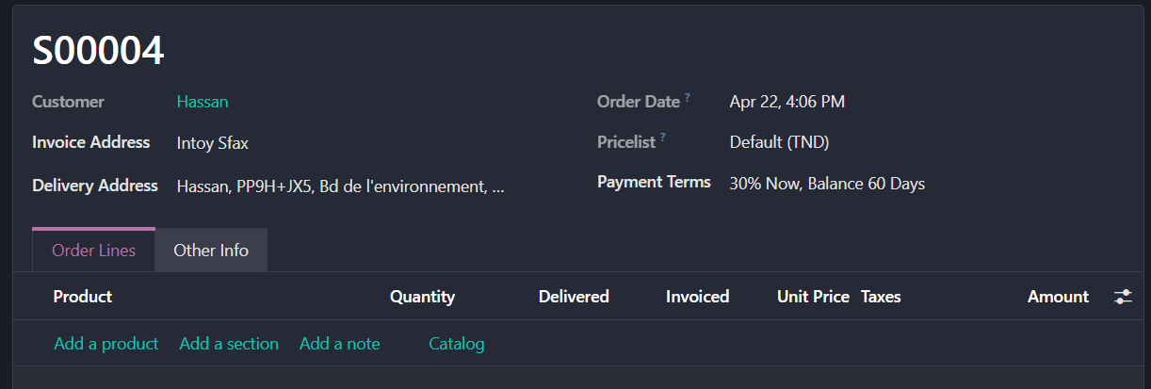

• For Suppliers: Purchases > Suppliers > Create
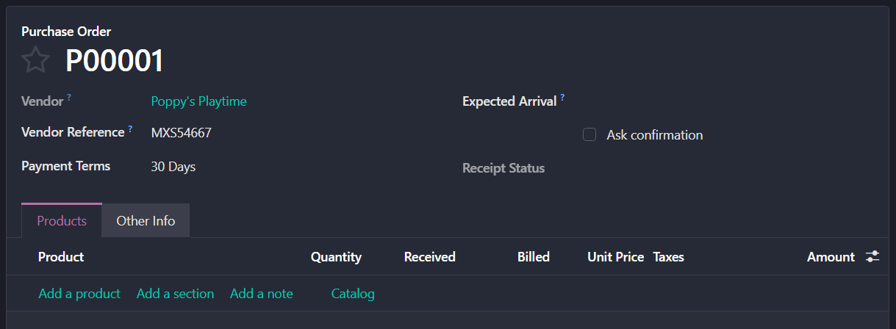
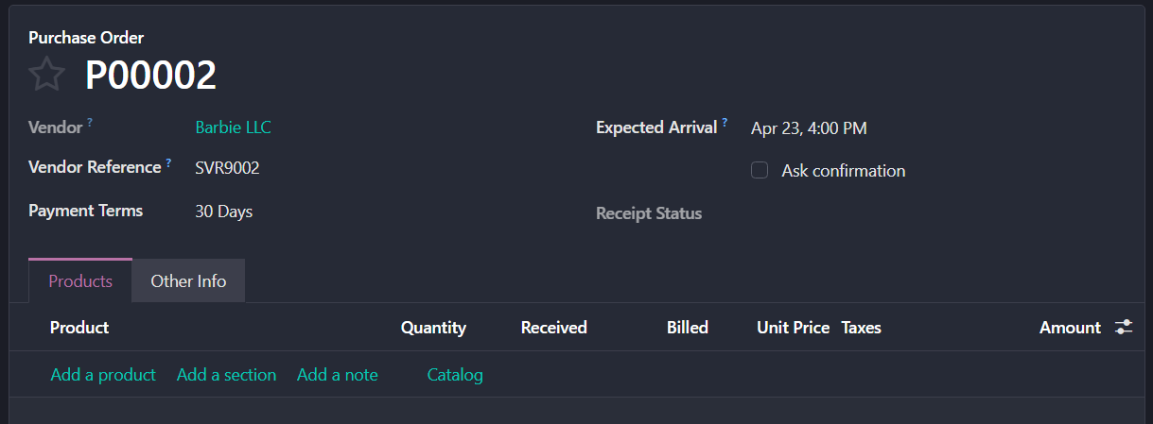
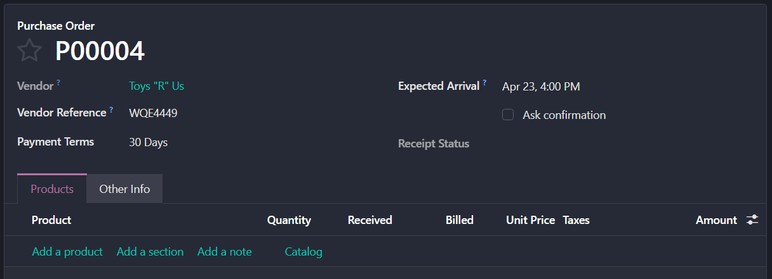
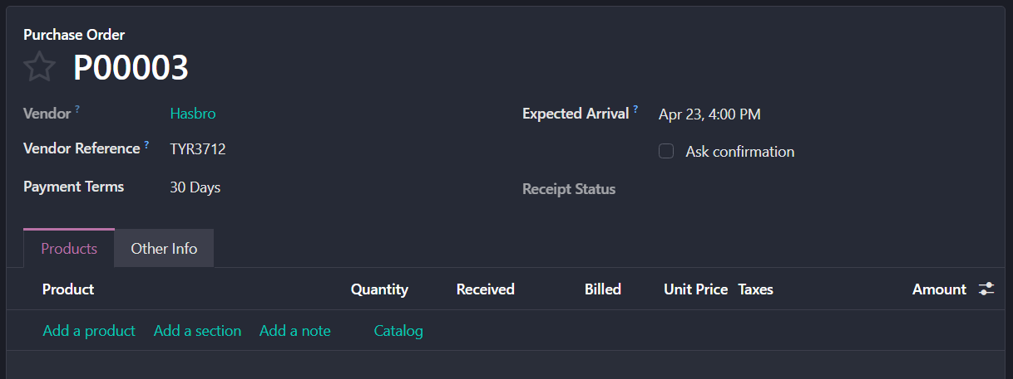

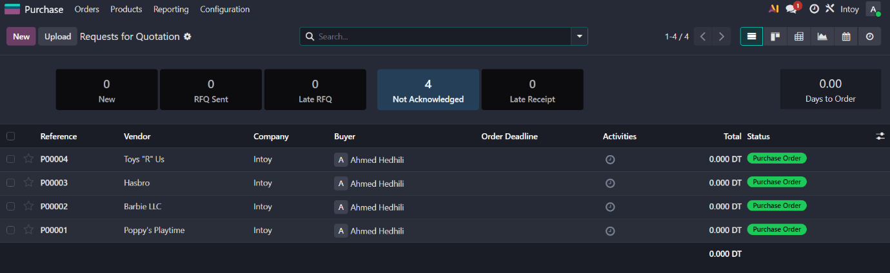

Activity 5: Product Management
To add products and services in Odoo, users typically navigate through the following menu paths:
• For Sales: Sales > Products > Create
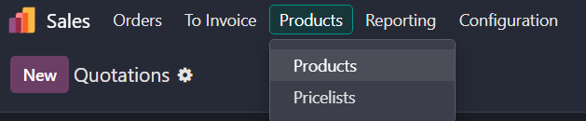
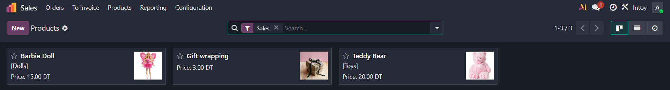
- Product Name:
Barbie Doll (Pink Dress with Butterfly Wings).
Saleable/Purchasable Status:
Saleable (a physical item that can be stored in inventory).
Product Type:
Storable product.
Sales Price:
15 TND.
Unit of Measure:
Unit (piece).
Supplier Information:
Supplier Name: Barbie LLC.
Purchase Price: 9 TND.
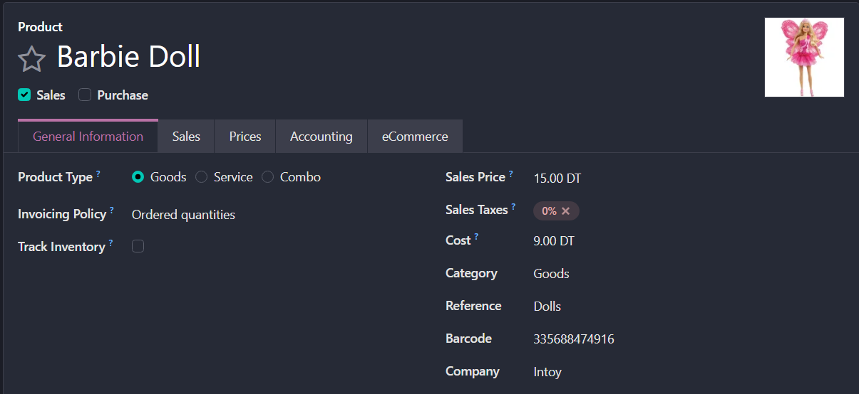
Delivery Lead Time: 5–10 days.

- Service Name:
Gift wrapping.
Saleable/Purchasable Status:
Saleable.
Product Type:
Service.
Sales Price:
3 TND per item.
Unit of Measure:
Unit (Service per item).
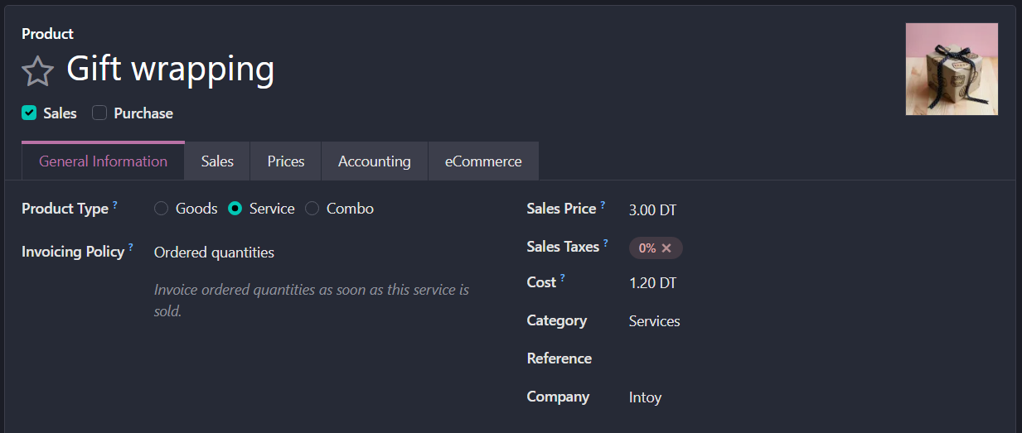
Supplier Information:
Not required.

- Product Name:
Small Plush Teddy Bear (Fluffy Faux Fur with Ribbon Bow) .
Saleable/Purchasable Status:
Saleable.
Product Type:
Storable product.
Sales Price:
20 TND.
Unit of Measure:
Unit (piece).
Supplier Information:
Supplier Name: Toys "R" Us.
Purchase Price: 12 TND.
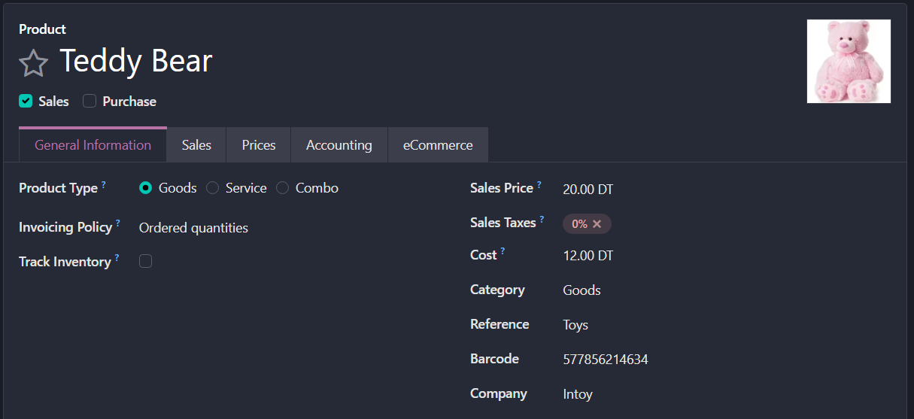
Delivery Lead Time: 5–10 days.

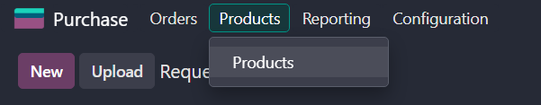
• For Purchases: Purchases > Products > Create

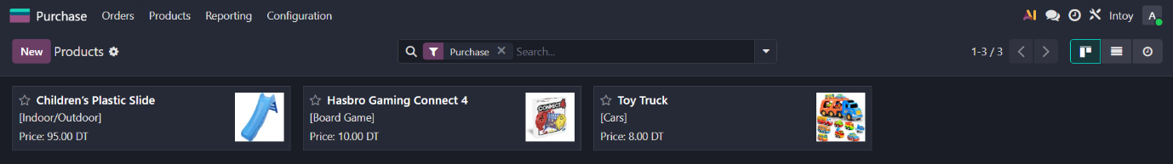
- Product Name:
Toy Transport Truck with Mini Vehicles set.
Saleable/Purchasable Status:
Purchasable.
Product Type:
Storable product.
Sales Price:
8 TND.
Unit of Measure:
Unit (Set).
Supplier Information:
Supplier Name: Toys "R" Us.
Purchase Price: 5 TND.
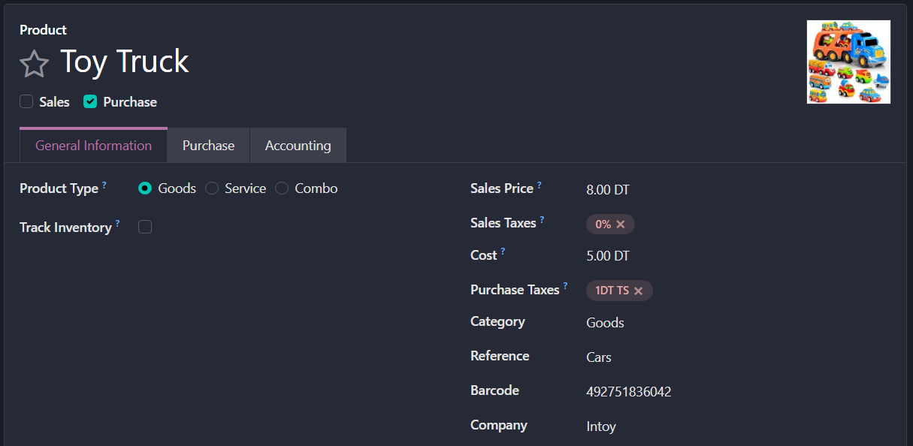
Delivery Lead Time: 5–10 days.

- Product Name:
Children’s Foldable Indoor/Outdoor Plastic Slide (Light Blue).
Saleable/Purchasable Status:
Purchasable.
Product Type:
Storable product.
Sales Price:
95 TND.
Unit of Measure:
Unit (Set).
Supplier Information:
Supplier Name: Toys "R" Us.
Purchase Price: 57 TND.
Delivery Lead Time: 10 days
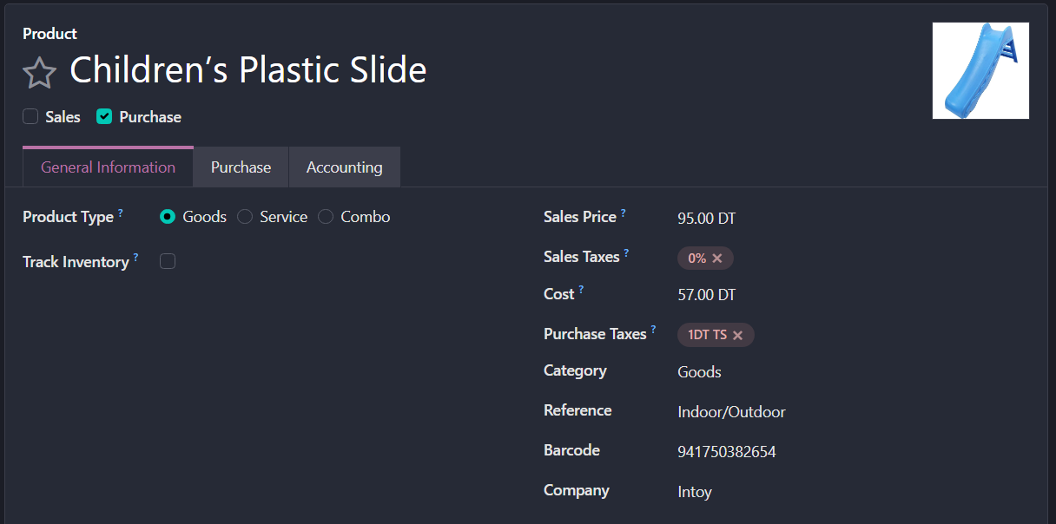
- Product Name:
Hasbro Gaming Connect 4 Classic Strategy Board Game
Saleable/Purchasable Status:
Purchasable.
Product Type:
Storable product.
Sales Price:
10 TND.
Unit of Measure:
Unit (as a single complete box set).
Supplier Information:
Supplier Name: Hasbro.
Purchase Price: 6 TND.
Delivery Lead Time: 5–10 days
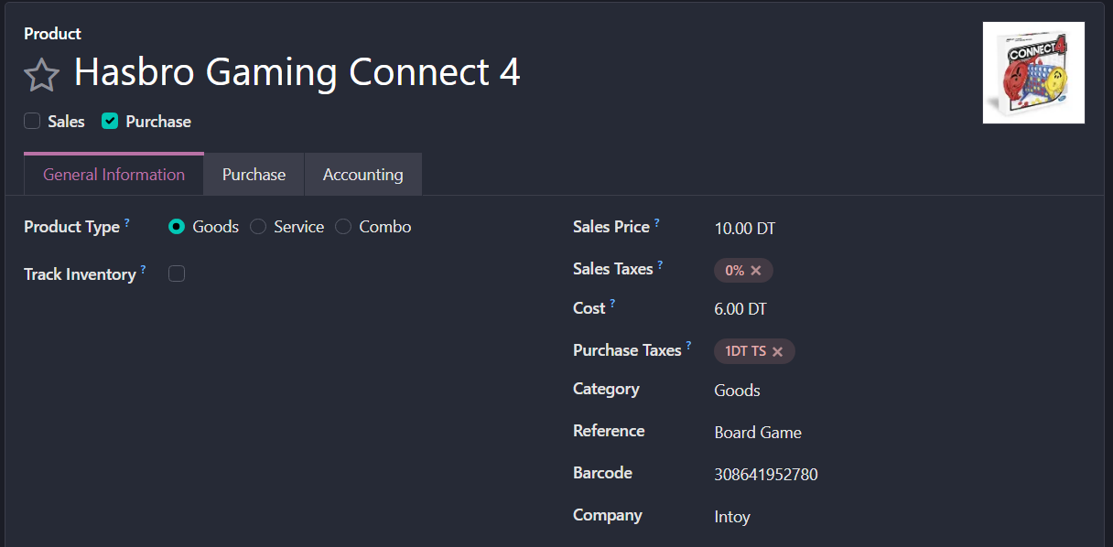

Activity 6: Inventory & Warehouse Management
To manage the toys and dolls efficiently, we need to define specific storage locations. In Odoo, this is done via:
Inventory > Configuration > Warehouses.
First, we need to install the Inventory's ERP model from Apps:
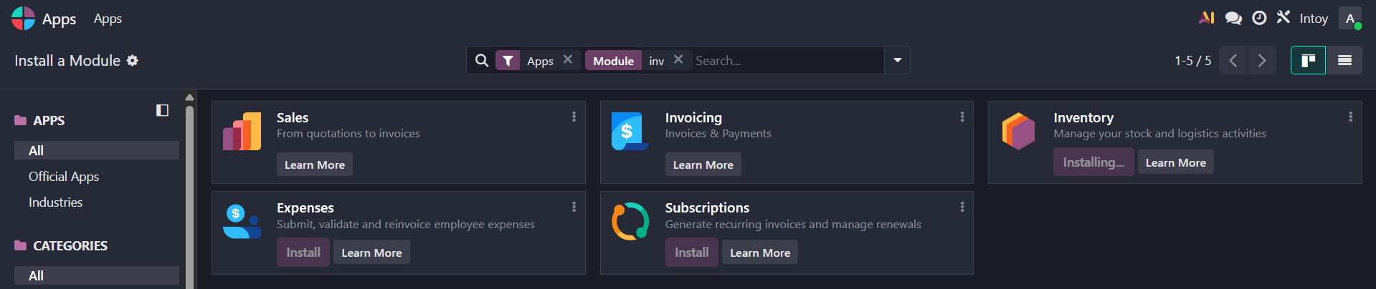

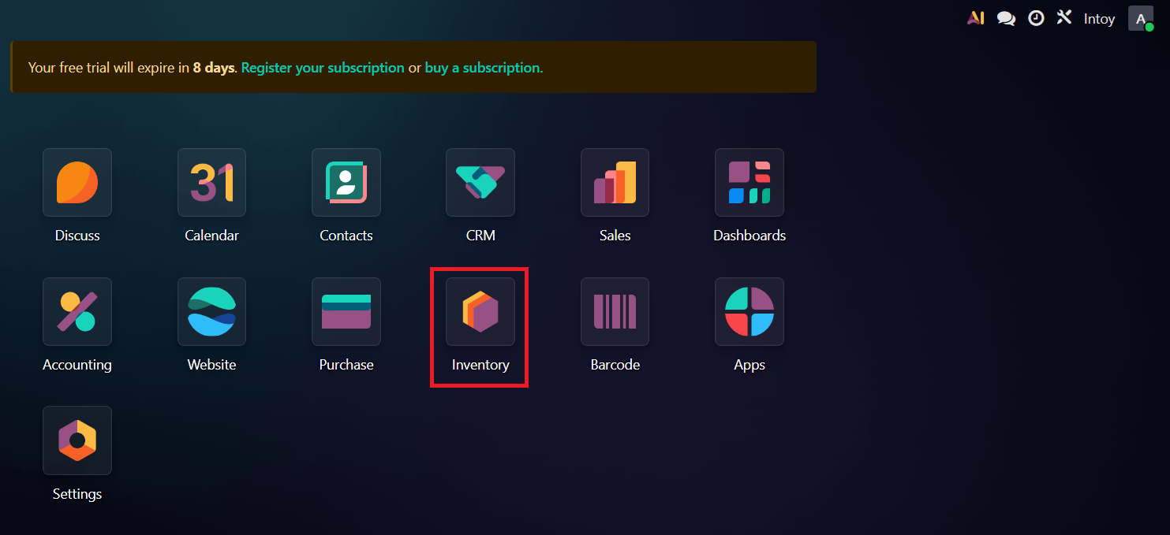

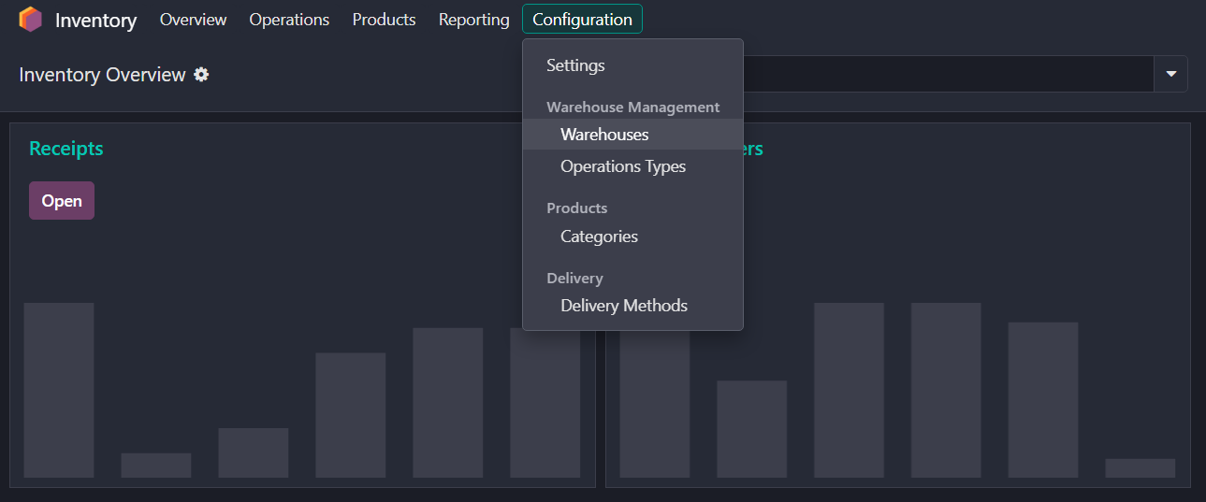
Proposed Warehouses:
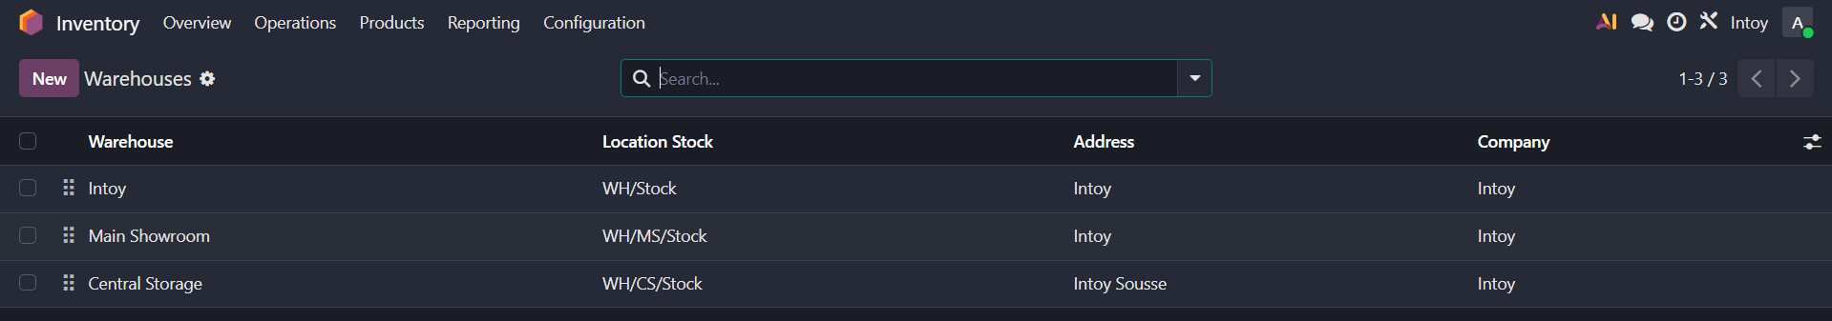

- Intoy Warehouse: the main and virtual warehouse for our store; it receives, stores and ships toys and dolls, and manages all of our company's inventory movements.
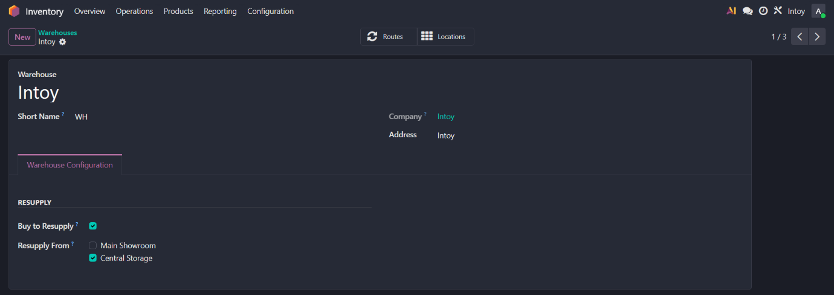

- Main Showroom (WH/Stock): The primary display area where customers browse and buy toys directly.
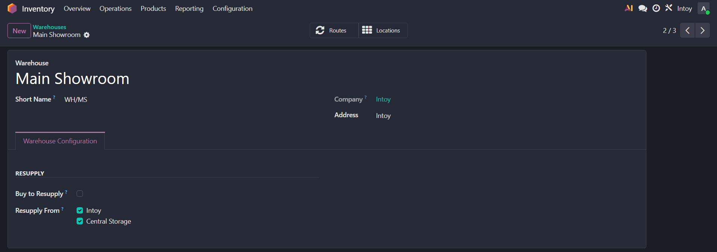
- Central Storage (WH/Storage): A back-end warehouse used for storing bulk quantities of dolls and large toy sets before they are moved to the showroom.
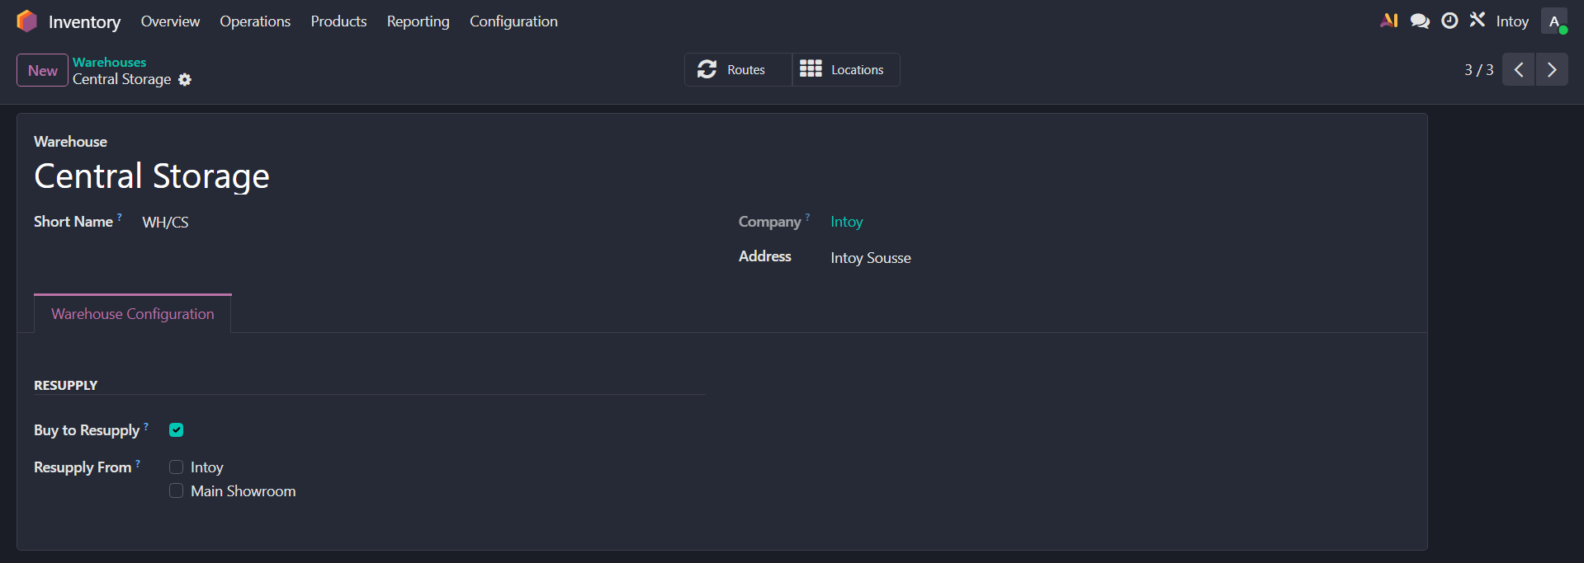

Activity 7: Purchasing Workflow
In this phase, we simulate the process of replenishing our toy stock from suppliers.
- Create Purchase Order (PO):
Purchases > Orders > Purchase Orders > Create

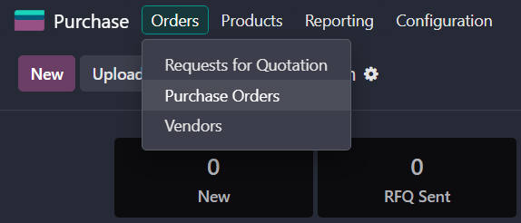

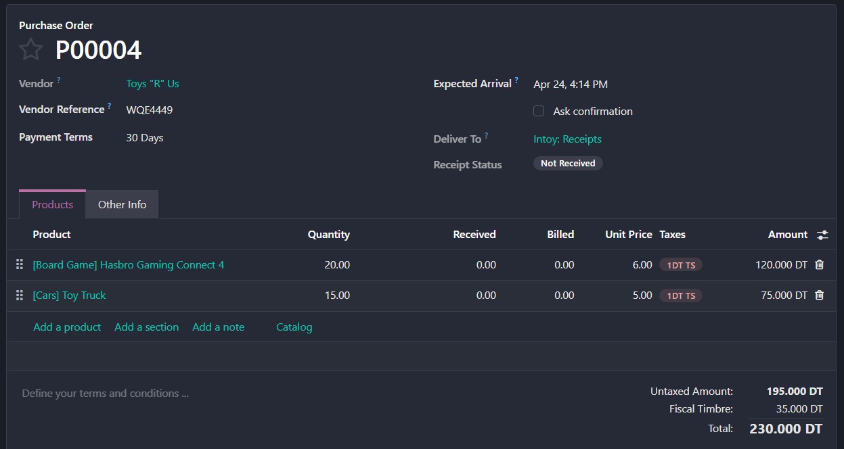
- Receive Products:
- Once confirmed, click the Receive Products button (this adds the toys to your Intoy warehouse).
- Click Validate to confirm you received the physical goods.
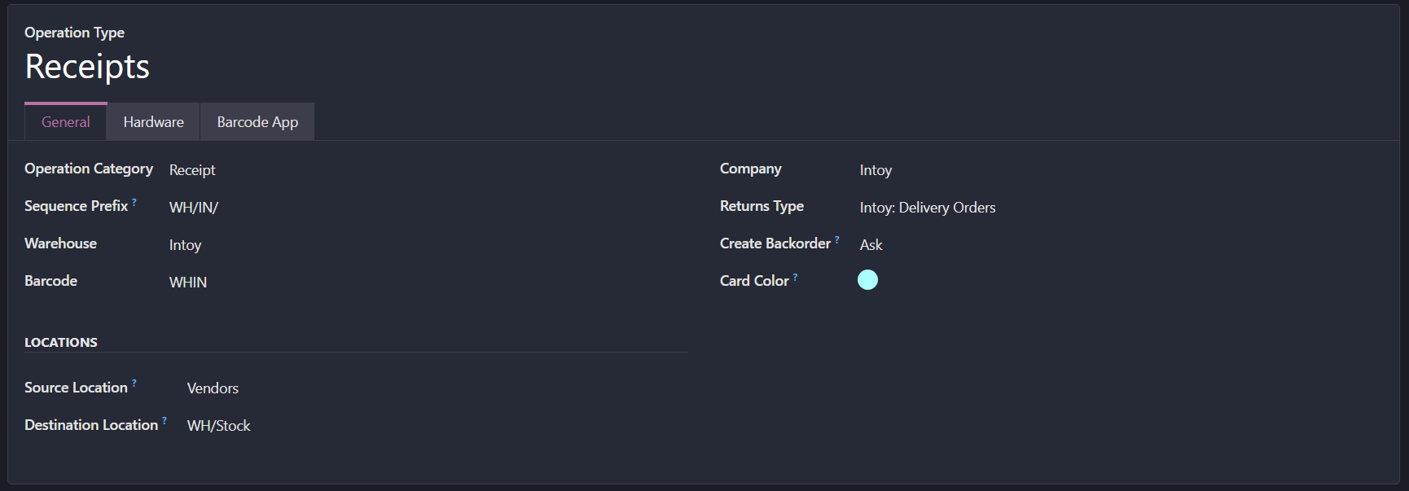

- Vendor Bill & Payment:
- Go back to the Purchase Order and click Create Bill.
- Confirm the bill to record it in accounting.
- Click Register Payment to complete the financial cycle.
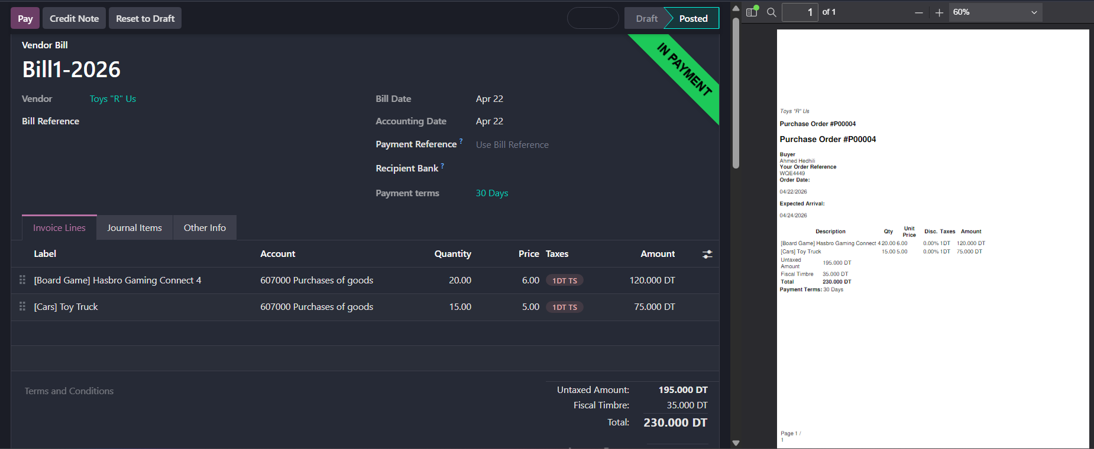
The second purchase
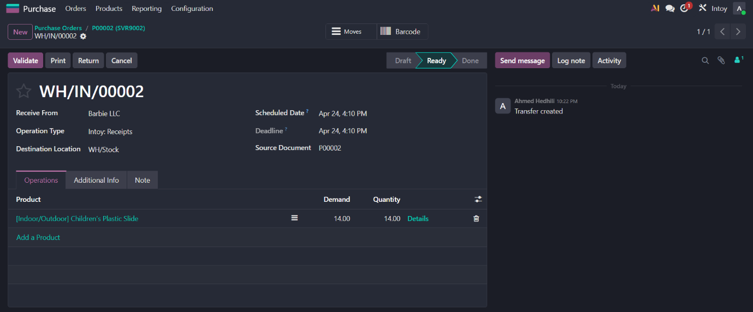

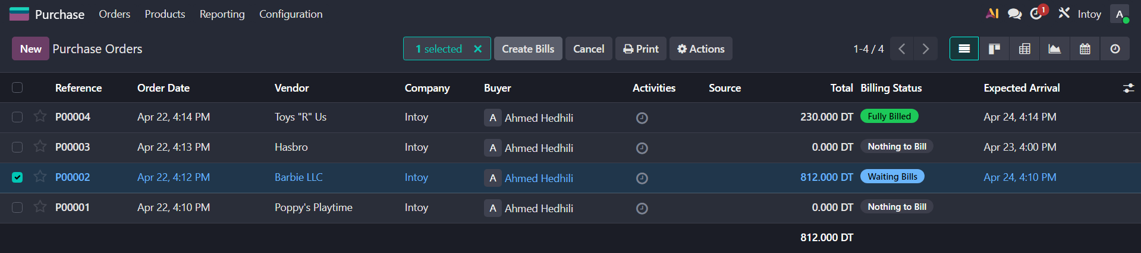

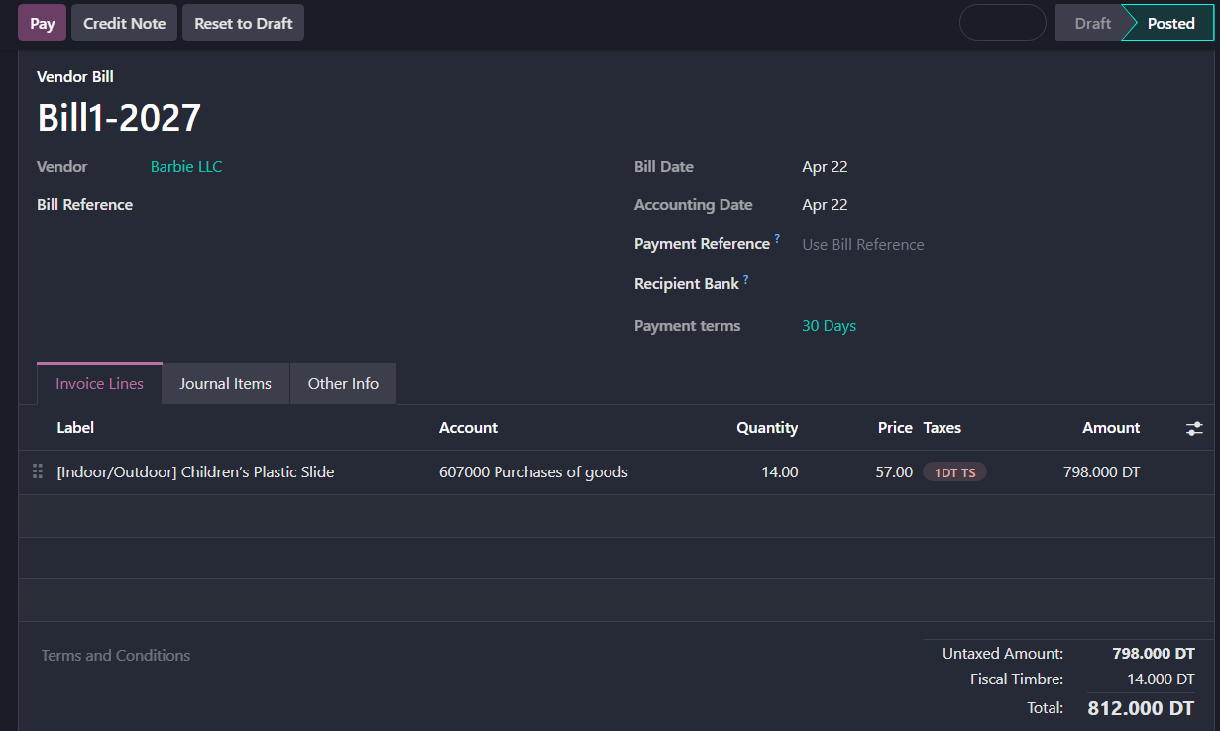

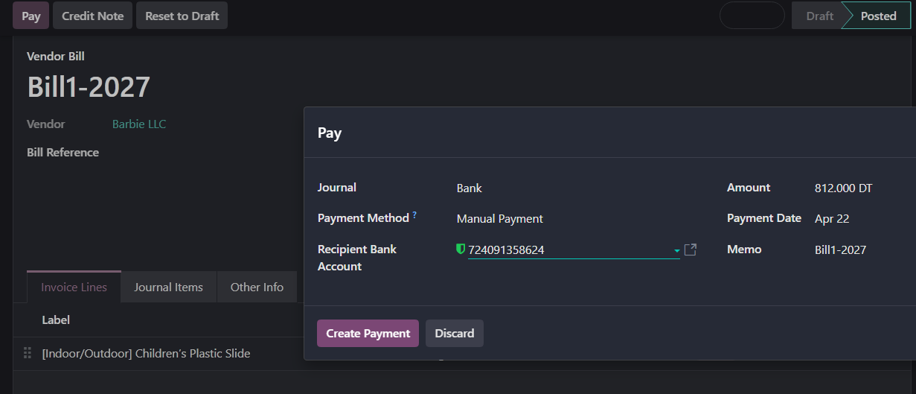
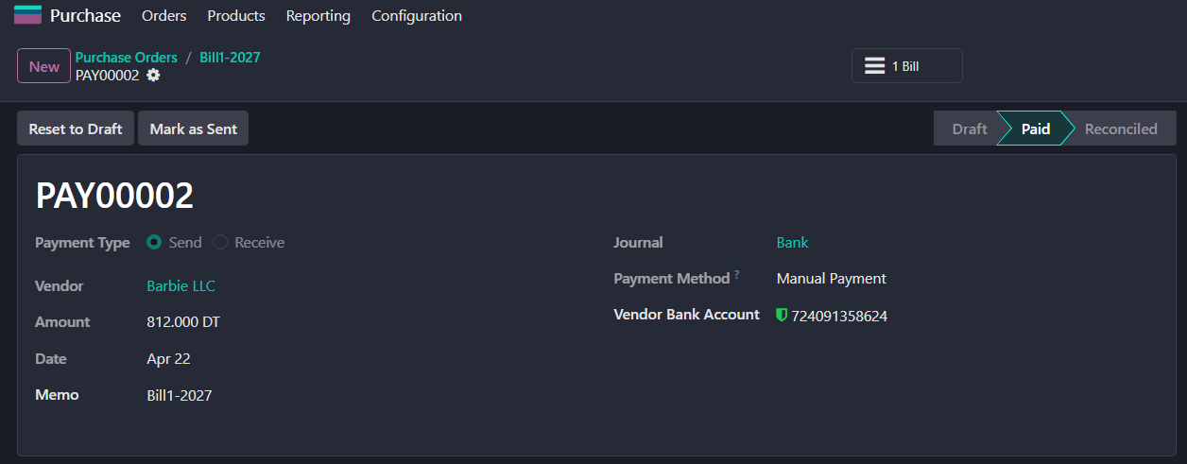
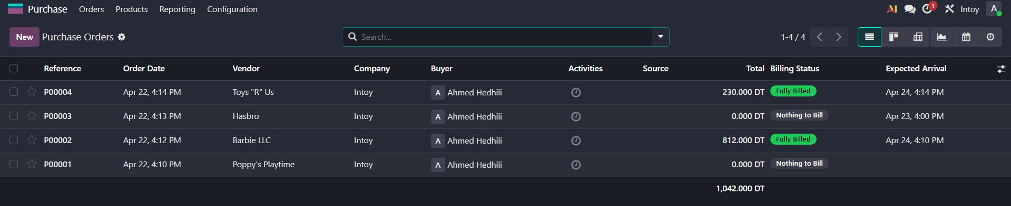

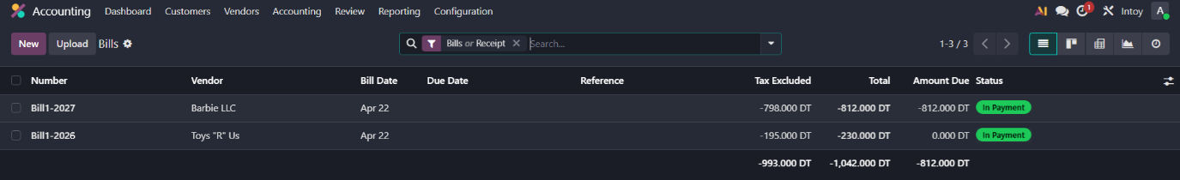

Activity 8: Sales & Inventory Audit
  - Sales Cycle
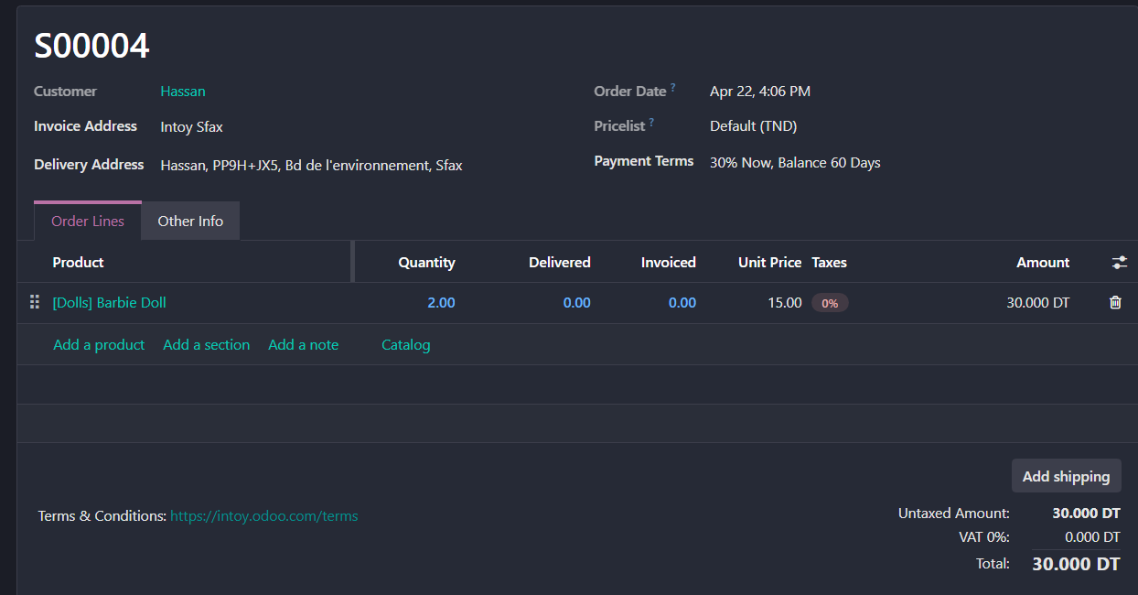
The first order:

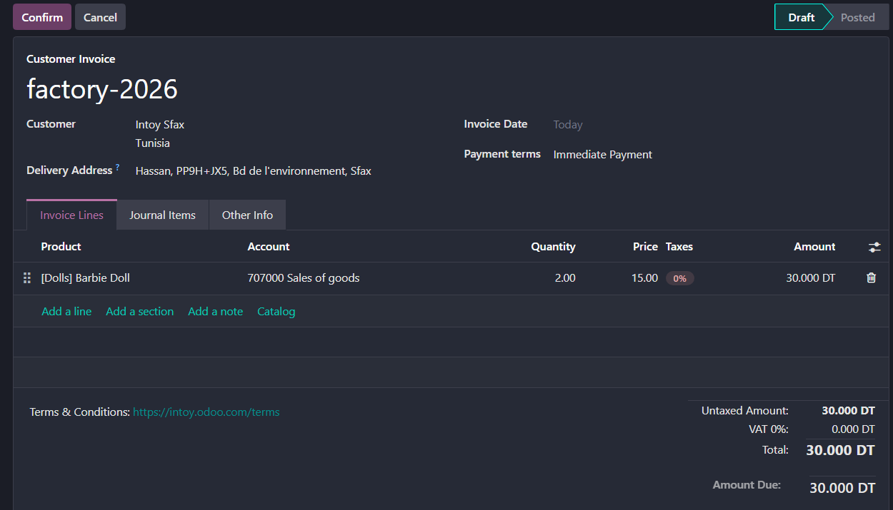
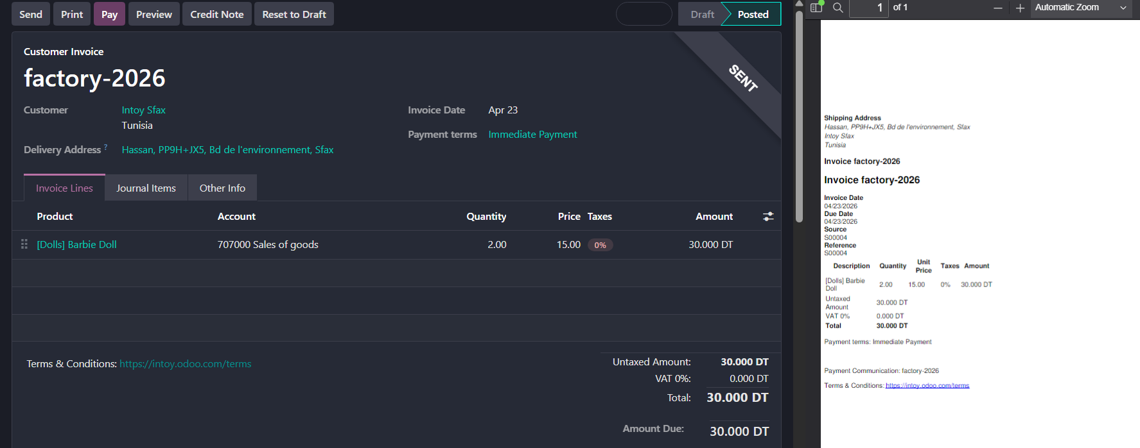
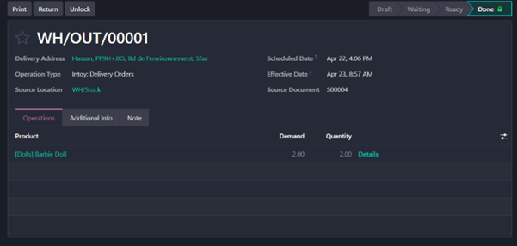
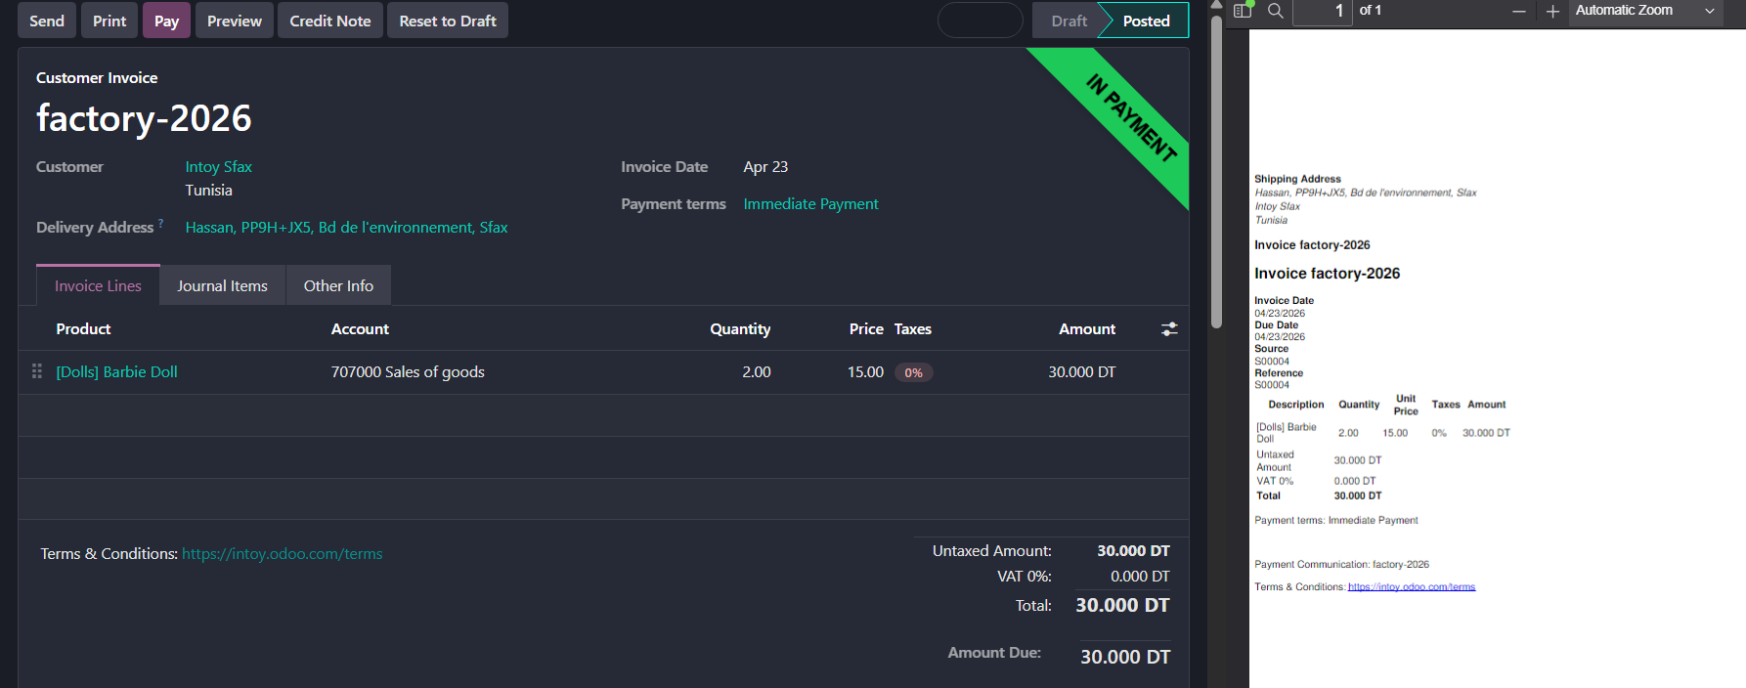

The second order
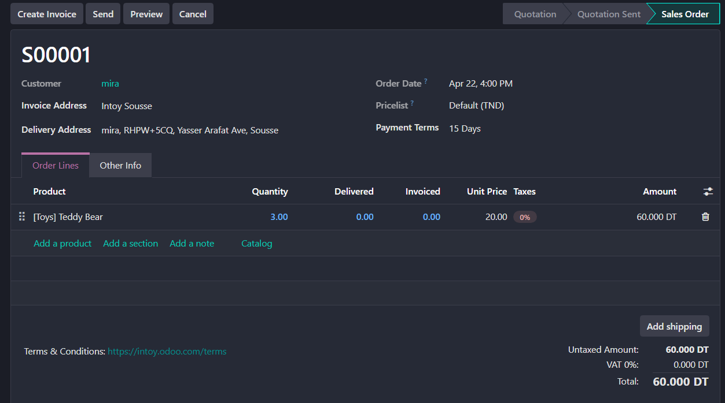
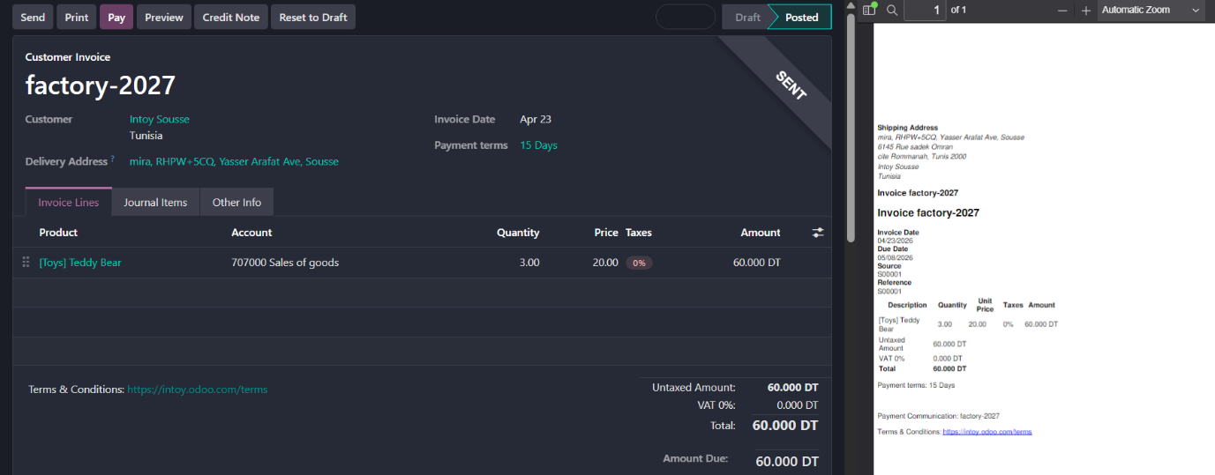
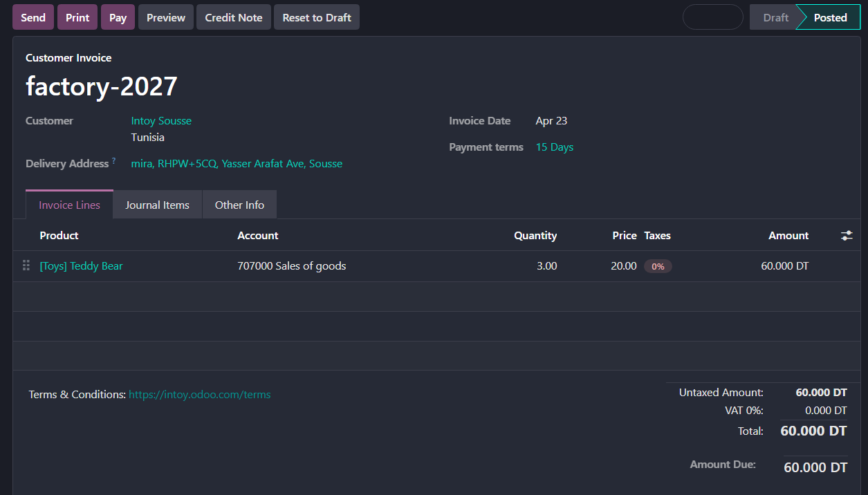

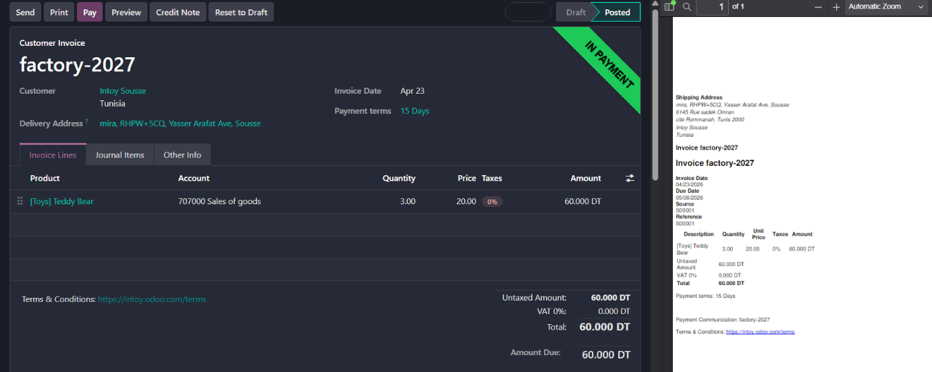

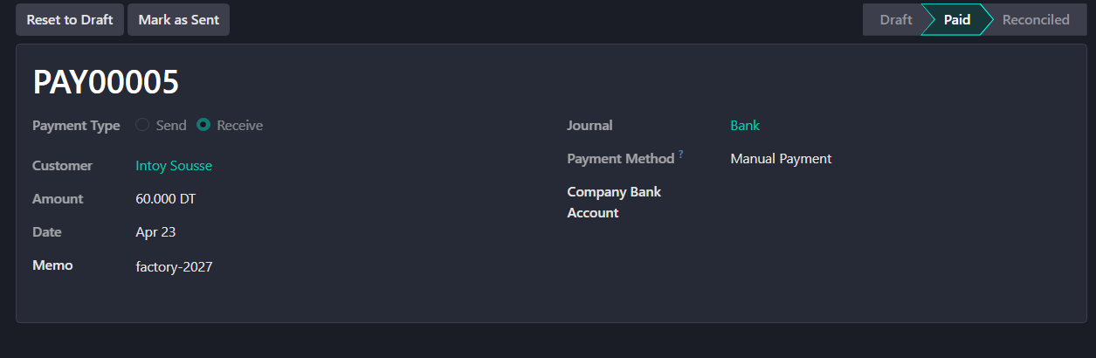

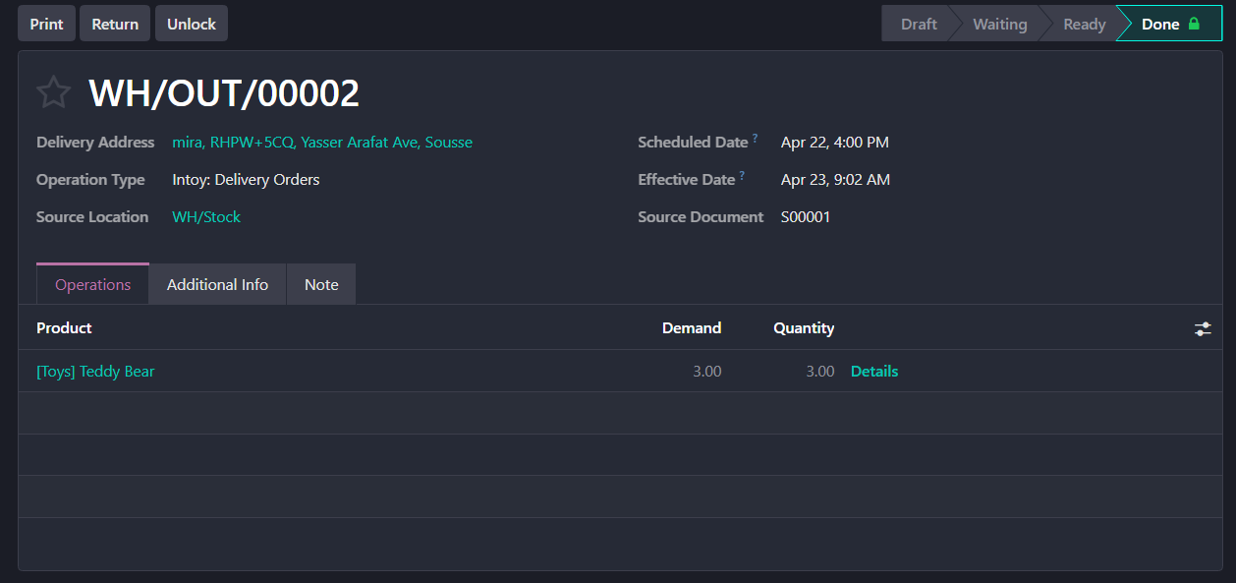

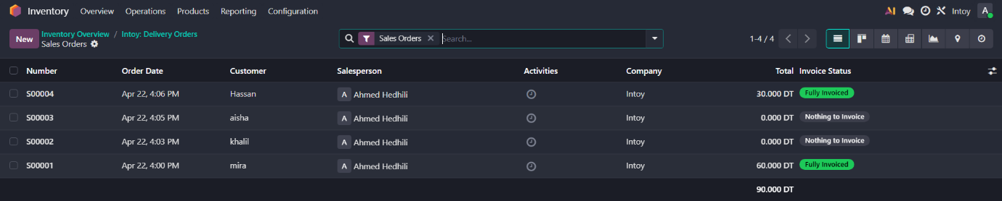

  - Inventory Audit/Physical Inventory
The goal is to ensure that the quantities on the shelves match what is recorded in Odoo.
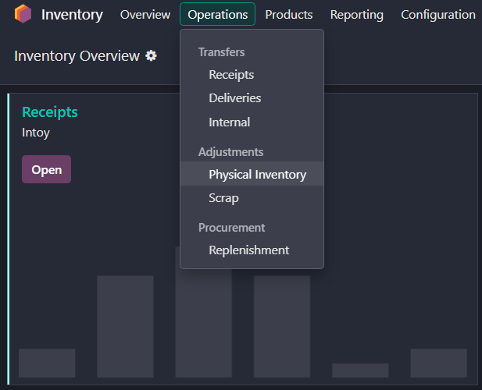

Activity 9: Payment Collection
We will focus on completing the payment collection process in accounting section.
  - Sales & Collection
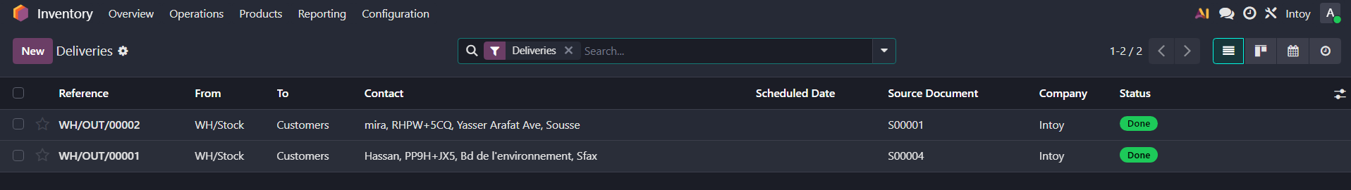
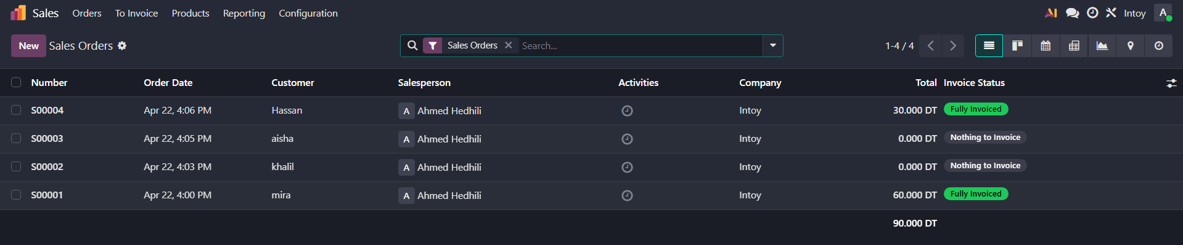

  - Reconciliation
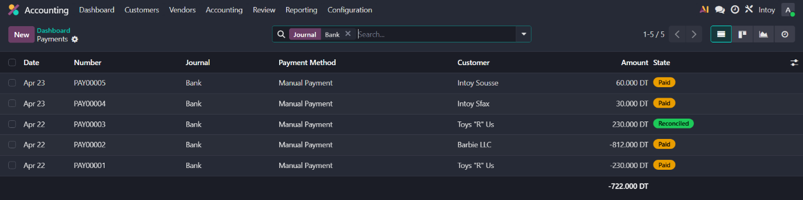
  - Inventory Audit
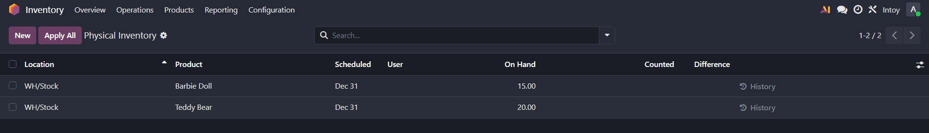

Conception with 2 models BPMN:
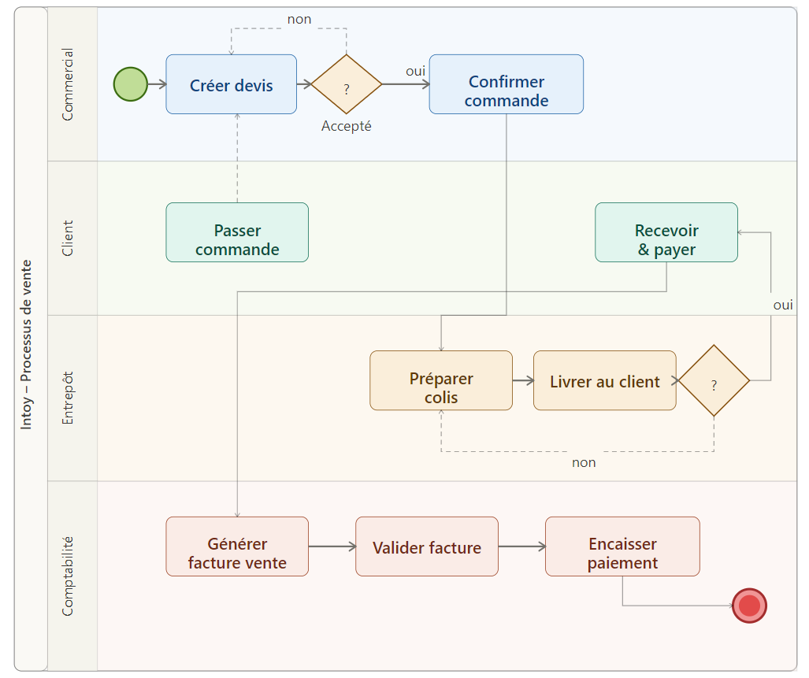
- Sales Process:

- Purchase approval:
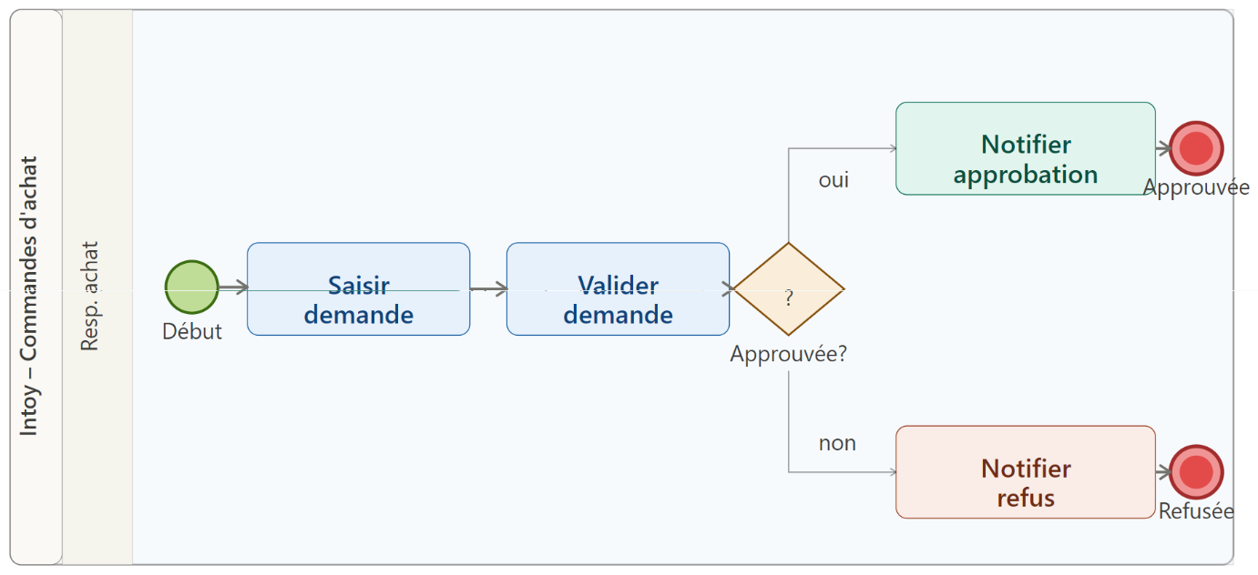

Final Conclusion
This project provided a comprehensive practical experience in implementing an ERP system using the Odoo platform for our toy shop, Intoy. By integrating core business modules—CRM, Sales, Purchases, Inventory, and Accounting—we successfully simulated a complete business lifecycle. We learned how to manage master data, automate workflows from procurement to payment collection, and ensure data consistency across departments. This implementation demonstrates how ERP systems enhance operational efficiency, reduce human error, and provide real-time insights for better decision-making in modern business environments.

Special Thanks: "We would like to express my sincere gratitude to Dr. Zakia ZOUAGHIA for her valuable guidance and support throughout this project, which greatly enhanced our understanding of ERP systems."

